AFM: Function Unit Day 1

Function:

Domain:

Range:

Interval Notation:

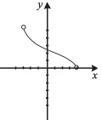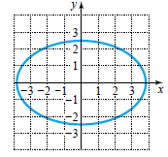 2. 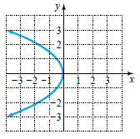 3.

1.

Function? Function? Function?

Domain: Domain: Domain:

Range: Range: Range:

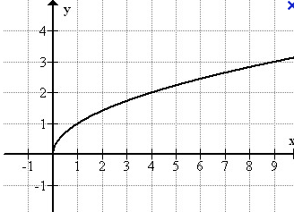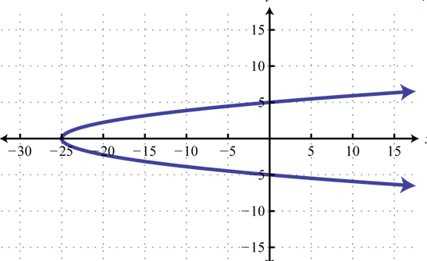

4. 5.

Function? Function?

Domain: Domain:

Range: Range:

f(4) = _________

f(x) = 3 when x=______

Increasing: Decreasing: Constant:

Determine the interval on which the function is increasing, decreasing, and constant.

1. 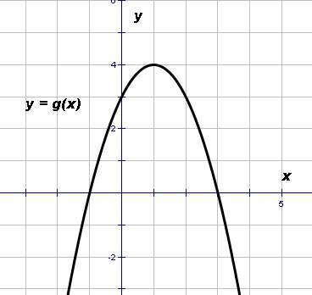 2.

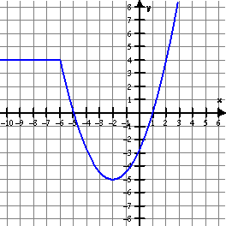

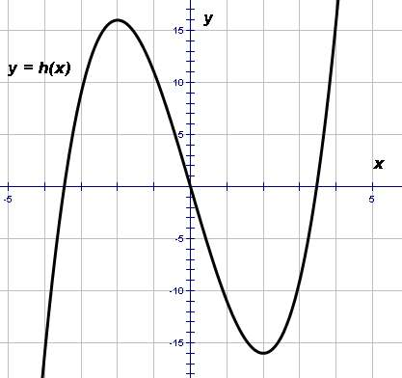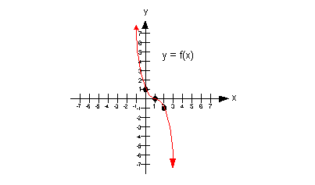

1. 4.

Graphs that are NOT continuous and putting it all together . . . find the domain, range, where increasing, decreasing, or constant.

5. 6.

