Name: ________________________ Date: ___________

Honors Math III Sketching Polynomial Functions

**Vocabulary**

Turning Point:________________________ Degree of a function:___________________

Local Max___________________________Absolute Max_________________________

Local Min___________________________Absolute Min_________________________

End behavior:

**For even degree polynomials, as and as**



**For odd degree polynomials, as and as**



Roots/x-intercepts/zeros (all mean same thing)

What does it do if its multiplicity is 1?__________________________________________

What does it do if its multiplicity is even?________________________________________

What does it do if its multiplicity is odd?_________________________________________

How do I start the graph?__________________________________________________

**RULE: If a function has degree _________ then the maximum number of roots (x-intercepts) is ________ and the function has a maximum of __________ turning points.**

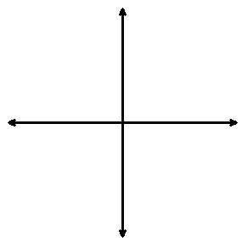

1. P(x) = x²(x-2)(x+2)

a. x-intercept(s):_____________

b. y-intercept:_____________

c. End Behavior: ____________

d. Behavior at the zeros (bounce/cross):

e. Possible number of turning points:________



2. 

a. x-intercept(s):_____________

b. y-intercept:_____________

c. End Behavior: ____________

d. Behavior at the zeros:

e. Possible number of turning points:________



3. 

a. x-intercept(s):_____________

b. y-intercept:_____________

c. End Behavior: ____________

d. Behavior at the zeros:

e. Possible number of turning points:________



4. 

a. x-intercept(s):_____________

b. y-intercept:_____________

c. End Behavior: ____________

d. Behavior at the zeros:

e. Possible number of turning points:________

**Use the graphs to fill in the blanks below:**

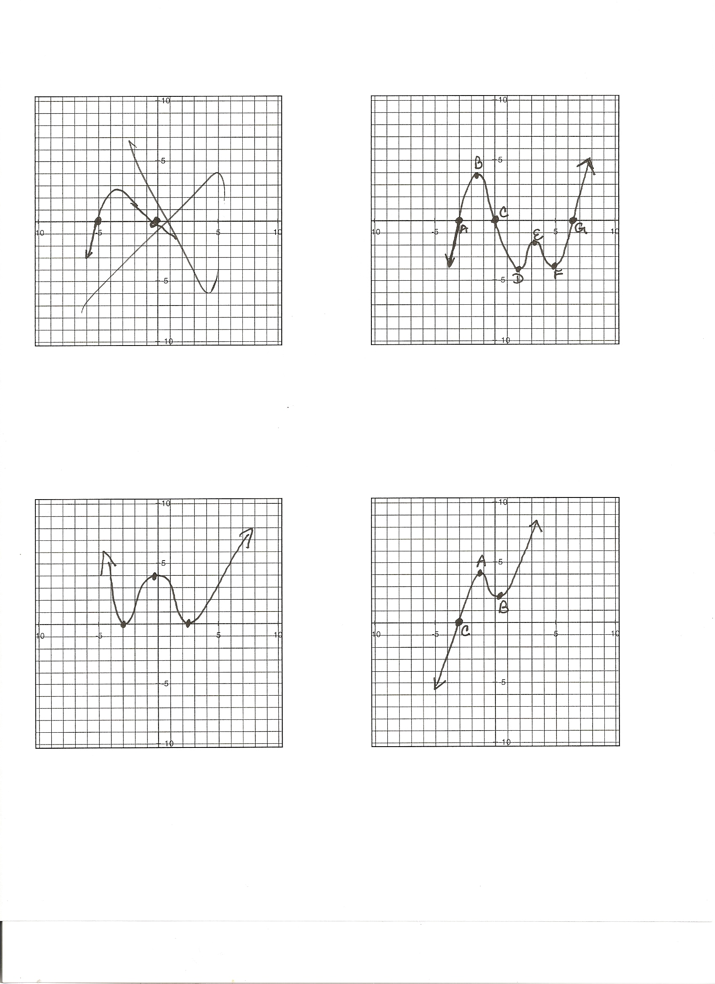

**Number T Pts: Number T Pts: Number T Pts:**

**Local Max: Local Max: Local Max:**

**Local Min: Local Min: Local Min:**

**Absolute Max: Absolute Max: Absolute Max:**

**Abs. Min.: Abs. Min.: Abs. Min.:**

**Least Degree: Least Degree: Least Degree:**