Graphing Sine and Cosine Name:____________________
- Let y = sin x where x = angle in RADIANS. Fill in the table of values and plot on the coordinate plane below.
x | -2π | -3π/2 | -π | -π/2 | 0 | π/2 | π | 3π/2 | 2π
y=sin x

Connect these points in a SMOOTH curve. Do NOT make it pointy.
This is the shape of the y = sinx curve.

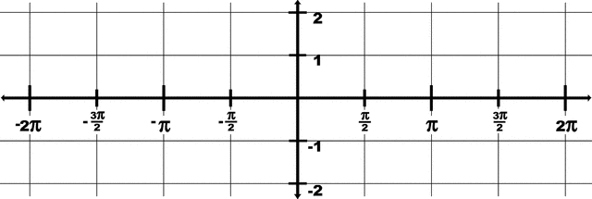

A periodic function is a function whose values repeat after a certain interval. The PERIOD refers to the length on the x axis that repeats itself.

Is y = sin x a PERIODIC function? If so, what is the period?

The AMPLITUDE of a function is found by ½(max – min). What is the AMPLITUDE of y = sin x?

On your calculator, change the MODE to Radians (not degrees). Under Y= put in sin x. Go to ZOOM and choose #7 (ZTrig). Note that the x-axis is from [-2π, 2π].
This should have given you the graph you did above. Make sure it is correct and fix it if not.

Graph y =3sinx. Describe how this is different from y = sin x. What is the amplitude? Period?

Graph y =-4 sin x. Describe how this is different from y = sin x. What is the amplitude? Period?

Graph y = sin 2x. Describe how this is different from y = sin x. What is the amplitude? Period?

Graph y = sin ½ x. Describe how this is different from y = sin x. What is the amplitude? Period?

Let’s generalize . . . if y = A sin Bx,

The AMPLITUDE is _______________ The PERIOD is _____________

- Let y = cos x where x = angle in RADIANS. Fill in the table of values and plot on the coordinate plane below.
x | -2π | -3π/2 | -π | -π/2 | 0 | π/2 | π | 3π/2 | 2π
y=cos x

Connect these points in a SMOOTH curve. Do NOT make it pointy. This is the shape of the y = cos x curve.

A periodic function is a function whose values repeat after a certain interval. The PERIOD refers to the length on the x axis that repeats itself.

Is y = cos x a PERIODIC function? If so, what is the period?

The AMPLITUDE of a function is found by ½(max – min). What is the AMPLITUDE of y = cos x?

On your calculator, make sure your MODE is set to Radians (not degrees). Under Y= put in cos x. Go to ZOOM and choose #7 (ZTrig). This should have given you the graph you did above. Make sure it is correct and fix it if not. Note that the x-axis is from [-2π, 2π].

Graph y =4 cos x. Describe how this is different from y = sin x. What is the amplitude? Period?

Graph y =-3 cos x. Describe how this is different from y = sin x. What is the amplitude? Period?

Graph y = cos 4x. Describe how this is different from y = sin x. What is the amplitude? Period?

Graph y = cos ½ x. Describe how this is different from y = sin x. What is the amplitude? Period?

Let’s generalize . . . if y = A cos Bx,

The AMPLITUDE is _______________ The PERIOD is _____________

SKETCH:
- Y = 3 cos 2x Describe the amplitude and period. Amp = ______ per=______

- Y = -4 sin x Describe the amplitude and period. Amp = ______ per=______

Give the amplitude and the period of the following:
- Y = 2 cos(4x) 2. Y = sin() 3. Y = cos (3x)

