**Unit 1: Piecewise Functions**

Objective 2.02 Use piece-wise defined functions to model and solve problems; justify results.

a) Solve using tables, graphs and algebraic properties.

b) Interpret the constants, coefficients, and bases in context of the problem.

|  |  |  |  |
| --- | --- | --- | --- |
| **DAY** | **TOPIC** | **ACTIVITY** | **HOMEWORK**  **(subject to change)** |
| **1**  Wed, 1/22 | Function: yes/no  Looking at and sketching different graphs of functions to find domain/range and where the graph is increasing/decreasing  Interval notation |  | p. 228-229 #1-3, 5-10 (for #7 and 10, also give intervals where incr, decr, and constant) |
| **2**  Thurs, 1/23 | Domains of functions without looking at the graph  Evaluating Functions |  | Practice sheet |
| **3**  Fri, 1/24 | More domain without graph review  Intro to Parent Functions |  | p. 217-218 #14, 17, 18, 22, 25, 29, 35-52 all - NO CALCULATORS |
| **4**  Mon, 1/27 | Transformations | **Quiz** (days 1-3)  Mini-project: Explore transformations | Transformation sheet |
| **5**  Tuesday,  1/28 | Transformations without calculators continued | Practice sheet | p. 256 #1-9 odd, 17-31 odd |
| **6**  Wednesday, 1/29 | Review and start piecewise functions (evaluating and graphing) | **Quiz on transformations**  Class notes worksheet | p. 217 #21-24, 59-71 odd, 72 |
| **7**  Thursday,  1/30 | Intro to Piecewise functions Applications of piecewise functions | Class notes worksheet | Practice sheet |
| **8**  Fri, 1/31 | Step Functions and Applications of piecewise functions continued |  | Practice sheet |
| **9**  Mon, 2/3 | Review | Study Guide wkst | Want extra practice?  P. 290-293 #1, 3, 7-12, 21, 23, 29-32, 53 |
| **10**  Tues, 2/4 | **Test** | **Test** |  |

AFM: Function Unit Day 1

Function:

Domain:

Range:

Interval Notation:

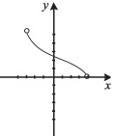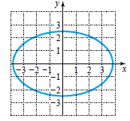 2. 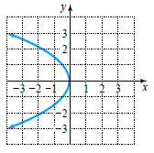 3.

1.

Function? Function? Function?

Domain: Domain: Domain:

Range: Range: Range:

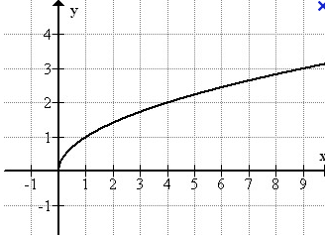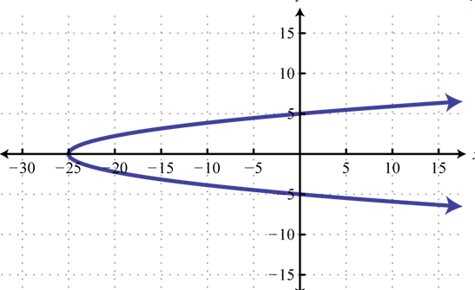

4. 5.

Function? Function?

Domain: Domain:

Range: Range:

f(4) = _________

f(x) = 3 when x=______

Increasing: Decreasing: Constant:

Determine the interval on which the function is increasing, decreasing, and constant.

1. 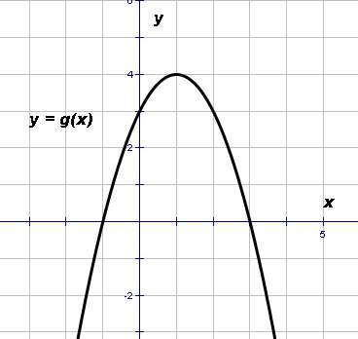 2.

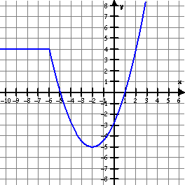

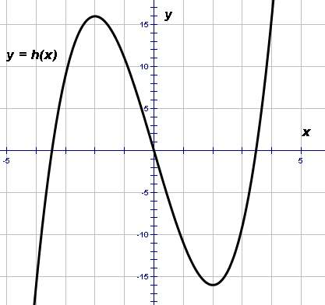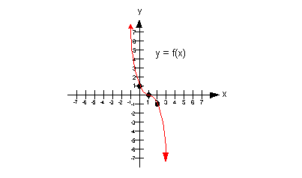

1. 4.

Graphs that are NOT continuous and putting it all together . . . find the domain, range, where increasing, decreasing, or constant.

5. 6.



**Day 2: Domain without Graphs Practice**

**Practice**

Find the domain of the functions

$f\left(x\right)=x^{2}+1$

$f\left(x\right)=5$

$f\left(x\right)=\frac{1}{x+1}$

$f\left(x\right)=x^{3}$

1. 
2. 
3. 
4. 
5. 
6. 
7. 
8. 
9. 
10. 

Evaluate the following functions:

1. f(x) = 4x – 5 a) f(3) b) f(-1) c) f(3a) d) f(a2)
2. g(x) = 3x2 – 4x + 1 a) g(2) b) g(-4) c)g(x+1) d) 2g(x) + 6
3. h(x) = 4x3 + x2 – 2x a) h(-1) b) h(2a2) c) h(-a) d) 3h(2)

 

Parent Functions

Graph each of the following functions. Use the table to help you come up with quality graphs! Label **at least 3 points** on your graph. THESE are graphs of functions that you will need to KNOW and be able to reproduce without help of a calculator!!

1. f(x) = x 2) f(x) = x2 3) f(x) = 

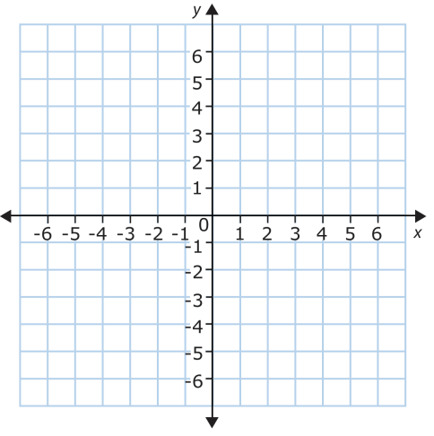  

Domain:_____________________ Domain:_____________________ Domain:_____________________

Range:______________________ Range:______________________ Range:______________________

Symmetry:__________________ Symmetry:_________________ Symmetry:__________________

4) f(x) = x3 5) f(x) =  6) f(x) = 2x

  

Domain:_____________________ Domain:_____________________ Domain:_____________________

Range:______________________ Range:______________________ Range:______________________

Symmetry:__________________ Symmetry:_________________ Symmetry:__________________

**Day 4** **Quiz Review**

**State the domain and range, where the graph is increasing, decreasing and constant in interval notation.**

1. 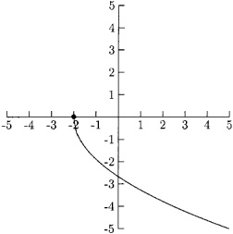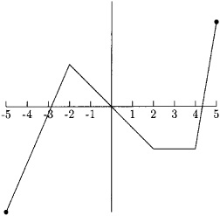 1 2.

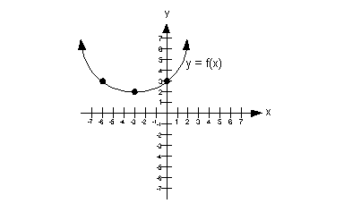

1. 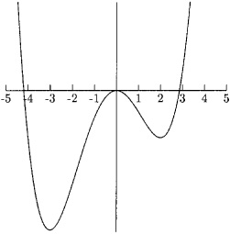 4.
2. **Find the domain of each of the following functions.**

$f\left(x\right)=x^{2}-3$

$f\left(x\right)=\frac{1}{x^{2}-6x+9}$

$f\left(x\right)=\frac{3x}{x^{2}-8x+15}$

$g\left(x\right)=\sqrt{3x-7}$

$f\left(x\right)=\left|x+4\right|$

$f\left(x\right)=\frac{\sqrt{x+1}}{x-7}$

**Evaluate the following functions:**

1. If $f\left(x\right)=x^{3}+2$, find:
2. f(-2) b) f(3) c) f(0) d) f(a)
3. Find $\frac{f\left(a-h\right)-f(a)}{h}$, $h≠0$ for $f\left(x\right)=-2x^{2}+1$