**Unit 2: Linear, Quad, and Power Functions**

Objectives:

|  |  |
| --- | --- |
| 1.01a | Create and use calculator-generated models for linear, polynomial, exponential, trigonometric, power, and logarithmic functions of bivariate data to solve problems. Interpret the constants, coefficients, and bases in the context of the data. |
| 2.03a | Use power functions to model and solve problems; justify results. Solve using tables, graphs, and algebraic properties. |
| 2.03b | Use power functions to model and solve problems; justify results. Interpret the constants, coefficients, and bases in the context of the problem. |

|  |  |  |  |
| --- | --- | --- | --- |
| **DAY** | **TOPIC** | **ACTIVITY** | **HOMEWORK**  **(you fill in)** |
| 1  Tues  2/11 | Review: Writing Equations of Lines (Algebra 1 and 2 Review) | * Review on linear functions * Practice with linear functions | P184-186 #5, 13, 17, 19, 27, 61, 65, 67 |
| 2  Mon  2/17 | Applications of linear | * Notes and practice sheet | Practice sheet |
| 3  Tues  2/18 | Quadratic Functions and Applications | * Calculator Keystroke Book * Notes Worksheet |  |
| 4  Wed  2/19 | More quadratics and review Symmetry and Even/Odd Functions  Intro to Power Functions | * Practice * Identify functions as odd/even/neither * Intro to Power Functions |  |
| 5  Thur  2/20 | Finish power functions  Start review | * **Quiz on linear and quadratic** * Review |  |
| 5  Fri  2/21 | Review |  | STUDY |
| 6  Mon  2/22 | TEST on Linear, quad, and power functions |  |  |

**Equations of Lines Extra Practice**

**Slope**

1. Find the slope of a line through A (-2, 1) and B(5, 7)

2. Find the rate of change for a baby who is 18 inches long at birth and 27 inches long at ten months.

. 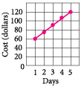

1. Write the equation in standard form

2. Write the equation in standard form

3. Write an equation in standard form and point-slope form that passes through the points (1, 4) and (-1, 1)

**Write and equation of a line perpendicular to the given line and passes through the given point:**

1. $y=-\frac{1}{3}x+2$ (4, 2)
2. $4x-2y=9$ (8, 12)

**Independent Variable**

**Slope-Intercept Form**

1. Write an equation of a line going through the points (3, 5) and (5, 9)in slope intercept form

2. Write an equation in slope intercept form of the line going through (2, 4)and has a slope of 3

1. Write an equation of a line in point-slope form with slope $\frac{2}{5}$ that passes through point (10, -8)

2. Write an equation for the line passing through the points (2, 5) and (4, 6) in point-slope form and in slope intercept form

**Standard Form**

**REMEMBER: No \_\_\_\_\_\_\_\_\_\_\_\_\_\_\_\_\_\_\_\_\_\_\_!**

**Horizontal/Vertical Lines**

**Parallel Lines**

**Perpendicular Lines**

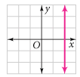 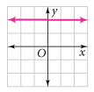

**Point-Slope Form**

**Write an equation of the line that is parallel to the given line and that passes through the given point**

1. $y=-6x-2$ (0, 0)
2. y $=-\frac{2}{3}x+3$ (-3, 6)

**Dependent Variable**

Find the x and y intercepts of the following equations.

1. 4*x* – 9*y* = –12
2. 2. 3x + 2y = 24
3. 3x + 4y = 8
4. Graph 2*x* + 3*y* = 12 using intercepts

**Intercepts**

**Equation of Line Practice**

1. Find the slope of the line through P(2, -5) and Q(-4, 3)
2. Find an equation of the line that satisfies the following conditions:
3. Through (-2, 4); slope of -1
4. Through (-3, -5); slope of -7/2
5. Through (-1, -2) and (4,3)
6. x-intercept 1; y-intercept -2
7. x-intercept -8; y-intercept 6
8. y-intercept 6, parallel to the line 2x+3y+4=0
9. Through (1/2, -2/3) perpendicular to the line 4x – 8y = 1
10. Find the slope and y-intercept of the line and draw its graph.
11. 3x-2y=12
12. -3x-5y+30=0
13. x=-5
14. Use the slope to determine whether the given points are collinear (line on a line)
15. (1, 1) (3, 9) (6, 21)
16. (-1, 3) (1, 7) (4, 15)

**Day 2: Applications of Linear Functions Notes**

Linear Applications

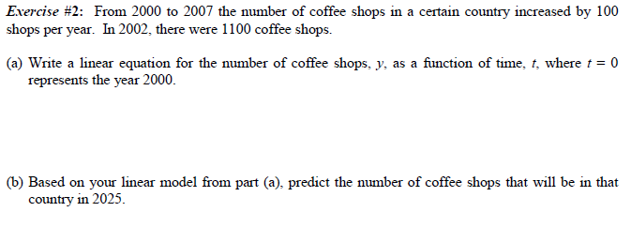

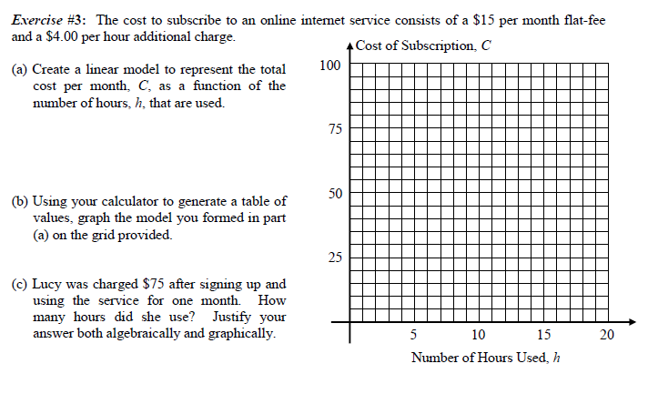

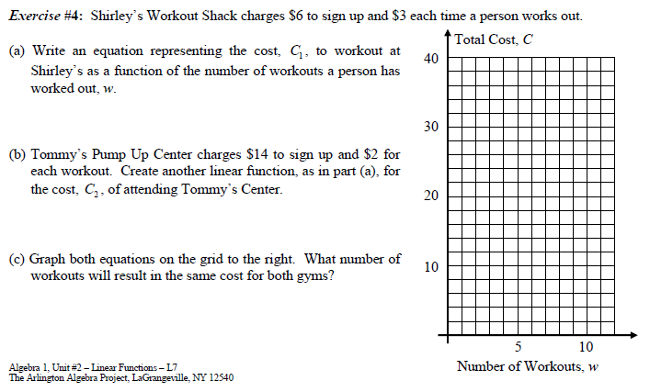

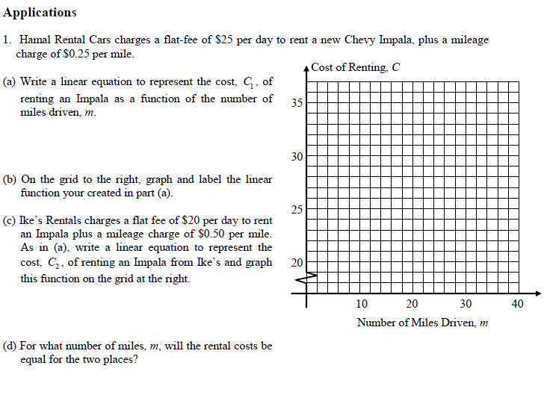

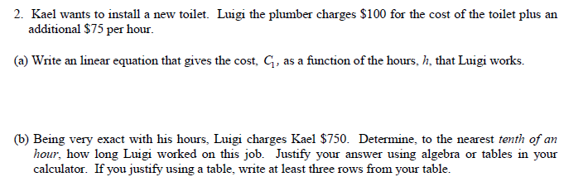

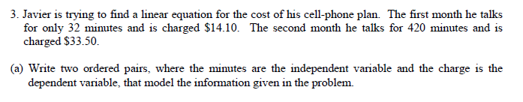

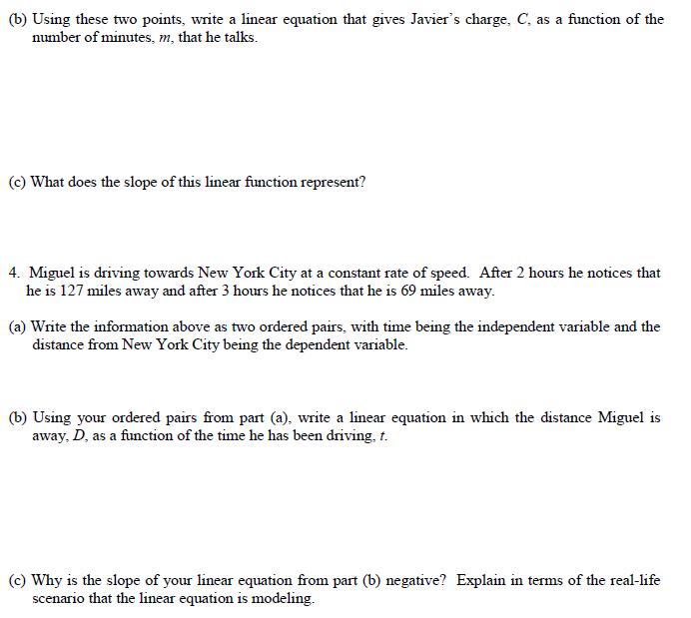

**AFM: Linear Application Practice Name:\_\_\_\_\_\_\_\_\_\_\_\_\_\_\_\_\_\_\_\_\_**

1. Tim earns $7 an hour working at McDonald’s. He also was given a signing bonus when he started of $25. Write an equation that represents Tim’s salary at McDonald’s.
2. The table below represents the cost of renting a movie for x amount of days. Write an equation that represents the cost of renting a movie.

|  |  |  |  |  |  |
| --- | --- | --- | --- | --- | --- |
| Days Rented (x) | 0 | 1 | 2 | 3 | 4 |
| Cost to Rent (y) | 12 | 15 | 18 | 21 | 24 |

b) What is the slope? What does it represent in the context of this problem?

1. Some scientists believe that the average surface temperature of the world has been rising steadily. The average surface temperature is given by

$$T=0.02t+7.50$$

where *T* is temperature in degrees Celsius and *t* is the time in years since 1990.

* 1. Find the slope. What does it represent?
  2. What does the 7.50 represent?

1. A pool is being drained such that the amount of water (in gallons) at any given time (in min) can be found by y = 20000 – 400x.
   1. What is the slope and what does the slope mean in terms of this application?
   2. What is the y-intercept and what does it represent in this application?
   3. What is the x-intercept and what does it represent in this application?
2. A small business buys a computer for $4000. After 4 years the value of the computer is expected to be $200. For accounting purposes, the business uses linear depreciation to assess the value of the computer at a given time. This means that if V is the value of the computer at time t, then a linear equation is used to relate V and t.
   1. Find a linear equation that relate V and t.
   2. Find the depreciated value of the computer 3 years from the date of purchase.
3. A candy store owner finds that if she produces x lollipops in a month her production cost is given by the equation y=0.4x + 1200 (where y is measured in dollars).
   1. What does the slope mean in terms of this application?
   2. What does the y-intercept of the graph represent in terms of this application?
4. The monthly cost of driving a car depends on the number of miles driven. Lynn found that in May her driving cost was $380 for driving 480 miles and in June her cost was $460 for 800 miles.
   1. Express the monthly cost C in terms of the distance driven, d assuming that a linear relationship gives a suitable model.
   2. Use part (a) to predict the cost of driving 1500 miles per month
   3. What is the slope and what does the slope of the line represent?
   4. What does the y-intercept of the graph represent?

Help with Quadratics

After you enter your equation, here are some questions that may be asked and here are steps on your calculator for finding them!

Remember x = time and y = height

1. When it asks you when the **object falls to the ground**, or when the height is at 0, you need to use the “zero” option on your calculator. The “zero” option b/c there is “0” height (it is at the ground). Go to 2nd trace #2 (this is the “zero” option). It will ask you for left bound and a right bound. Just go to the left of where the graph is crossing the x-axis and press enter. Now scroll with your arrow key until you are to the right of the x-axis. Press enter. Press enter one more time. (Notice the 2 arrows up at the top of your screen, they should be pointing towards one another, not away from each other, if so, your left and right bounds are backwards). Notice it says zero at the bottom after you have pressed enter. X = number, y = 0. Again, b/c y = height and since it is at the ground, there is no height. X is the desired time it takes to reach the ground. That is your answer!

2. The **highest peak** at which the object is in the air is found under 2nd trace 4 (maximum). Again it will ask you the left and right bounds of the max. Just go to the left of the max, press enter, go to the right press enter and press enter again. The x = time it takes to reach the maximum height and y = the maximum height. (Same thing goes if you want to find the minimum, but it is 2nd trace # 3)

3. If it asks you when an object **will be at a certain height,** then you need to go back to y= and in y2, put the height in which you are referring to. If you go back to your graph, you will see the horizontal line going through your quadratic equation. You want to find the intersection. Go to 2nd trace #5 (intersect) and get your cursor right on the intersection of the two and press enter 3 times. The x again tells you the time and y = ht in which you put into y2. There may be 2 intersections. One for the height of the object on the way up in the air and other on the way back down.

**Formulas to know:**

Perimeter: P = 2l + 2w

Area of Rectangle: A = lw

Area of Triangle: A = ½ bh

**Day 3: Quadratic Functions – Algebra**

* Standard Form:
* Graph:
* Ways to solve:

**Example 1:**

* The product of 2 consecutive *positive* integers is 110. Find the integers.

**You Try!**

* The product of two consecutive odd integers is 195. Find the integers.

**Example 2:**

* The base of a triangle is 2 meters less than the altitude and the area of the triangle is 364 m2. Find the altitude.

**You Try!**

* A rectangular building lot is 8 ft longer than it is wide and has an area of 2900 ft2. Find the dimensions of the lot.

**Example 3:**

* The perimeter of a rectangle is 24cm and the area is 32 cm2. Find the dimensions.

**Example 4:**

* The larger of two positive numbers is five less than twice the smaller. If their products is 63, find the smaller number.

**Example 5:**

* An object is thrown or fired straight upward at an initial speed of v0 ft/s. It will reach a height of h feet after t sec, where h and t are related by the formula h=-16t2+v0t. Suppose that a bullet is show upward with an initial speed of 800 ft/s.

h=-16t2+800t

When does bullet fall back to ground?

When does it reach a height of 6400?

When does it reach a height of 2 miles?

How high is the highest point the ball reaches?

**Read each problem carefully and completely answer all questions. Solve algebraically or by using the calculator to graph each parabolic equation. Set your window so that the entire graph is shown in the view screen.**

1. MCj03328320000[1]**Are You Ready For Some Football?** The height of a punted football can be modeled with the quadratic function . The horizontal distance in feet from the point of impact with the kicker’s foot is *x*, and *h* is the height of the ball in feet.
2. What is the ball’s height when it has traveled 30 ft downfield?
3. What is the maximum height of the punt? How far downfield has the ball traveled when it reaches its maximum height?
4. The nearest defensive player is 5 ft horizontally from the point of impact. How high must he get his hand to block the punt?
5. Suppose the punt was not blocked but continued on its path. How far down field would the ball go before it hit the ground?
6. Why is the linear equation  not a good model for the path of the football? Explain.
   1. **More Football** Although a football field appears to be flat, its surface is actually shaped like a parabola so that rain runs off to either side. The cross section of a field with synthetic turf can be modeled by  where *x* and *y* are measured in feet.
7. What is the field’s width?
8. What is the maximum height of the field’s surface?

Source: Boston College

* 1. PE03257_[1]**Newspaper Circulation** The function describes newspaper circulation (in millions) in the United States for 1920 to 1998 (where is used for 1920). Identify periods of increasing and decreasing circulation.

1. According to the function, when did newspaper circulation peak?
2. When will circulation approximate 45 million?
   1. **Manufacturing** An electronics company has a new line of portable radios with CD players. Their research suggests that the daily sales *s* for the new product can be modeled by , where *p* is the price of each unit.
3. Find the maximum daily sales.
4. What price will result in that maximum?
   1. MCj02025820000[1]**Architecture** The shape of the Gateway Arch in St. Louis, Missouri, is a catenary curve, which loosely resembles a parabola. The function  models the shape of the arch, where *y* is the height in feet and *x* is the horizontal distance from the base of the left side of the arch in feet.
5. According to the model, what is the maximum height of the arch?
6. What is the width of the arch at the base?
   1. **Field Hockey** Suppose a player makes a scoop that releases the ball with an upward velocity of 34 ft/s. The function  models the height *h* in feet of the ball at time *t* in seconds. Will the ball ever reach a height of 20 ft? Explain.
   2. **Throwing A Ball** A player throws a ball up and toward a wall that is 17 feet high. The height *h* in feet of the ball *t* seconds after it leaves the player’s hand is modeled by . If the ball makes it to where the wall is, will it go over the wall or hit the wall? Explain.
   3. **Business** The weekly revenue, *R*, for a company is , where *p* is the price of the company’s product. When will the weekly revenue reach $1500? Explain.
   4. **AN01125_Woodland Jumping Mouse** The woodland jumping mouse can hop surprisingly long distances given its small size. A relatively long hop can be modeled by  where *x* and *y* are measured in feet.
7. How far can a woodland jumping mouse hop?
8. Can a woodland jumping mouse jump a tree stump that is 3.5 ft high?

Source: University of Michigan Museum of Zoology

**Intro to Power Functions**

**Odd:**

**Symmetric about the \_\_\_\_\_\_\_\_\_\_\_\_\_\_**

**Neither:**

**Even:**

**Symmetric about the \_\_\_\_ axis**

**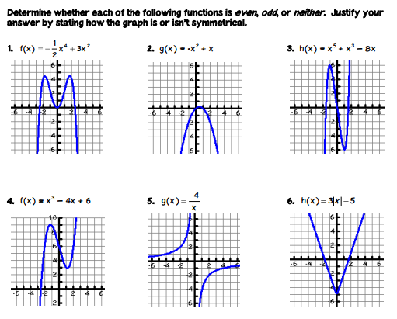**

Determine using symmetry and algebraically whether the following functions are even, odd, or neither.

|  |  |  |
| --- | --- | --- |
| 1. f(x)= 4x – 3  [image] | 2. f(x)=  [image] | 3. f(x)= -x2 – 4  [image] |
| 4. f(x)= x3  [image] | 5. f(x)= 7x  [image] | 6. f(x)=  [image] |

7. f(x)= 3x2 8. f(x) = x3 – 2 9. f(x)= 3x + 4

10. f(x)= x2 – 5 11. f(x)= 10x + 5 12. f(x)= 2(x+1)3

**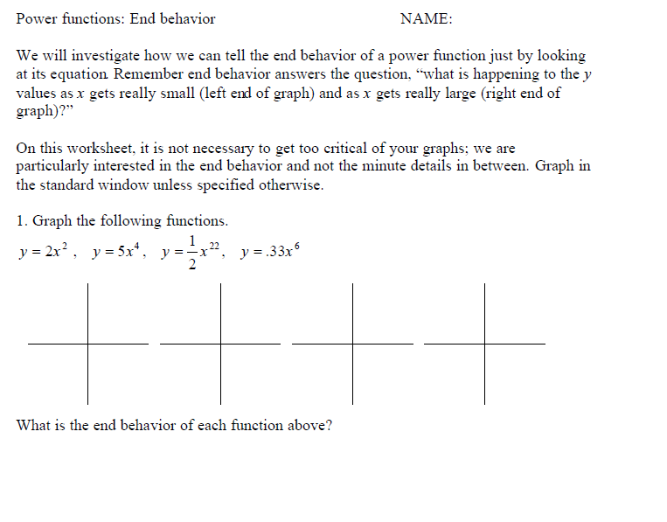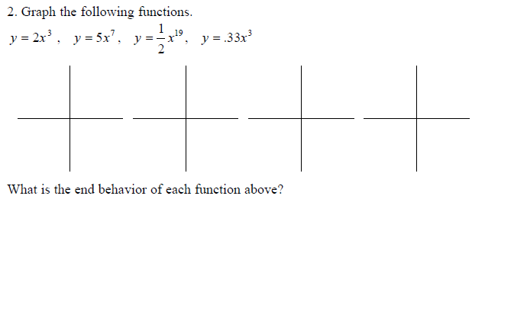**

**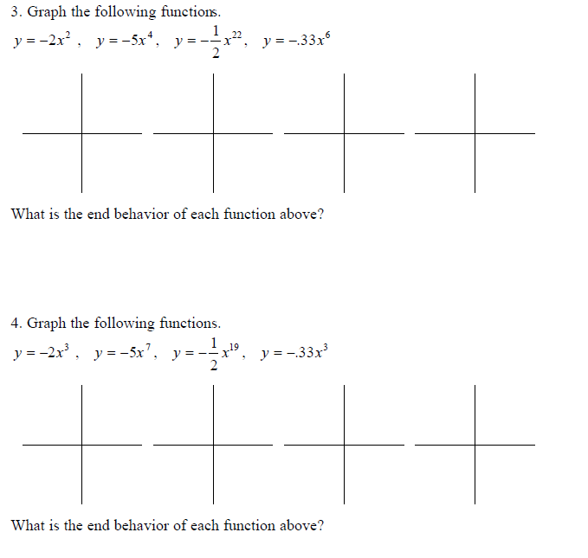**

**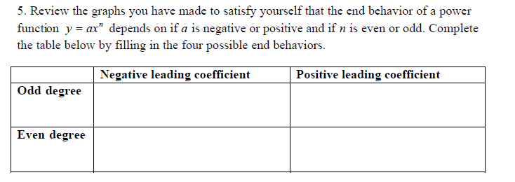**

Unit 2 Study Guide: Linear and Quadratic

1. Find the equation of a line that passes through (1, 2) and has a slope of $-\frac{2}{3}$
2. Find the equation of a line that passes through (-3, -1) and (2, 4).
3. Find the equation of a line with an x-intercept of -2 and a y-intercept of 4.
4. Find equation of a line that passes through ($\frac{1}{4}$, $-\frac{3}{5}$) and is perpendicular to the line 2x – 3y = 1.
5. Explain (in complete sentences) whether the given points are collinear (lie on a line): (5, -2) (7,6) and (10, 18)
6. The table below shows the cost, C, in dollars, of selling x cups of coffee per day from a cart.

|  |  |  |  |  |  |  |
| --- | --- | --- | --- | --- | --- | --- |
| X | 0 | 5 | 10 | 50 | 100 | 200 |
| C | 50.00 | 51.25 | 52.50 | 62.50 | 75.00 | 100.00 |

* 1. Using the table, show that the relationship appears to be linear
  2. Find the slope of the line. Explain what this means in the context of the problem.
  3. Find the y-intercept. IN regards to the context of the given information, explain what the y-intercept tells us and why it is that amount.
  4. Give an example of interpolation and extrapolation.

1. A theatre manager graphed weekly profits as a function of the number of patrons and found that the relationship was linear. One week of profit was $11,328 when 1324 patrons attended. Another week 1529 patrons produced a profit of $13,275.50.
   1. Find a formula for weekly profit, y, as a function of the number of patrons, x.
   2. Interpret the slope, using complete sentences.
   3. Interpret the y-intercept, using complete sentences.
   4. What is the break-even point (the number of patrons for which there is zero profit)?
   5. Find the formula for the number of patrons, x, as a function for weekly profit, y.
   6. If the weekly profit was $17,759.50, how many patrons attended the theatre?
2. The table shows the height in feet, h(t), t seconds after a ball is thrown upward.

|  |  |  |  |
| --- | --- | --- | --- |
| T(seconds) | 0 | 1 | 3 |
| H(t) (feet) | 72 | 112 | 96 |

1. Explain why a quadratic model is appropriate and then find a quadratic function that models this data.
2. Find the maximum height attained by the ball.
3. When is the ball at its maximum height?
4. When is the ball at 85 feet above the ground?
5. When does the ball hit the ground?
6. Find two numbers whose sum is 11 and product is 24.
7. The sum of the squares of 2 consecutive odd integers is 290. Find the integers.
8. The height of a triangle is 2 cm less than twice its base. The area is 112cm2. Find the height and base.
9. Are the following functions even, odd or neither? How do you know?

a. f(x) = -3x5/4 b. f(x) = x-4 c. f(x) = 2x3