Name: _________________________
Unit 4: Triangle Trigonometry
Objective 2.04 Use trigonometric (sine, cosine) functions to model and solve problems; justify results.
- Solve using tables, graphs, and algebraic properties.
- Create and identify transformations with respect to period, amplitude, and vertical and horizontal shifts.
- Develop and use the law of sines and the law of cosines.

Day | Topic | Class work | Homework
1  Monday, 3/10 | 6.2 Right Triangles  -trig ratios  -solving right triangles  -omit problems like | Notes given out (this is section 6.2 in your text) | Rt triangle Wkst - Odds
2  Tuesday, 3/11 | Applications |  | Page 464-466 #5, 13, 21, 31, 39, 41, 49, 51, 53, 55, 56
3  Thursday, 3/13 | 6.4 Law of Sines  (ambiguous case too) |  | Page 486 #3-7odd, 13, 17,19, 21, 25, 32, 33, 35, 36
4  Friday, 3/14 | Continue 6.4  6.3 Area of Triangle | Quiz 1  (Days 1-2) | Wkst
5  Monday, 3/17 | 6.5 Law of Cosines |  | Page 493#3, 5, 9, 13, 19, 21, 23, 37-39, 45, 47, 49
6  Tuesday, 3/18 and Wed 3/19 | Review | QUIZ – Law of Sines and Area | Worksheet Study Guide
7  Thursday 3/20 | TEST | TEST

Warm Ups:
Day 2:
- A ladder leans against a building. The foot of the ladder is 6 feet from the building. The ladder reaches a height of 14 feet on the building.
- Find the length of the ladder
- To the nearest degree, what angle does the ladder make with the ground?
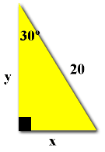
- Find x and y

- From the top of a barn 25 feet tall, you see a cat on the ground. The angle of depression of the cat is 40º. How many feet, to the nearest foot, must the cat walk to reach the barn?
Day 4: Quiz Review
- A triangle has an acute angle such that $sinθ=\frac{3}{7}$. Find the other five trigonometric ratios.
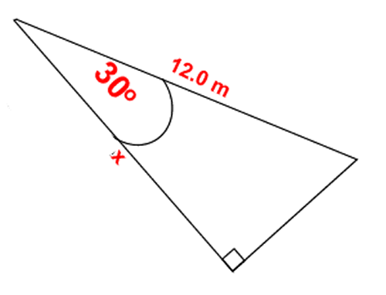
- Find the side labeled x

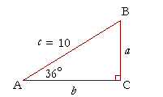
- Solve the triangle.

- A 30 foot flagpole casts a shadow of 135 feet long. What is the angle of elevation?

- The angle of depression from the top of a 180 m cliff to a log cabin is 42º. How far is the cabin from the foot of the cliff?
Day 5:
- John wants to measure the height of a tree. He walks exactly 100 feet from the base of the tree and looks up. The angle from the ground to the top of the tree is 33º. This particular tree grows at an angle of 83º with respect to the ground rather than vertically (90º). How tall is the tree?

- A building is of unknown height. At a distance of 100 feet away from the building, an observer notices that the angle of elevation to the top of the building is 41º and that the angle of elevation to a poster on the side of the building is 21º. How far is the poster from the roof of the building?

- Triangle ABC has ∠A=32 , ∠B=81.8 , and side a = 42.9 inches. What is the measure of side c?
Day 7:
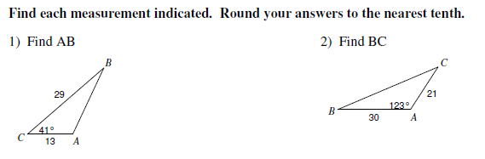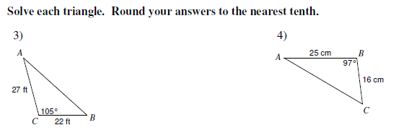
Day 8: Test Review
- Find the six trigonometric ratios given that $\sin{θ}=\frac{9}{41}$

- If a = 20, b = 33.3, and c = 24, find the biggest angle.

- A building is 50 feet high. At a distance away from the building, an observer notices that the angle of elevation to the top of the building is 41º. How far is the observer from the base of the building?

- Given triangle ABC with sides: a = 8, b = 3, c = 9, solve the triangle.

- An observer is near a river and wants to calculate the distance across the river. He measures the angle between his observations of two points on the shore, one on his side and one on the other side, to be 28º. The distance between him and the point on his side of the river can be measured and is 300 feet. The angle formed by him, the point on his side of the river, and the point directly on the opposite side of the river is 128º. What is the distance across the river?

Day 1: Things to recall from Geometry about right triangles:

- The angles of a triangle add up to 180 degrees.
- One angle is 90 degrees, therefore leaving the other angles to be acute (less than 90 degrees). Why? Because if the angles add up to 180 and one is 90, the other two have to be less than 90 together or otherwise it would be greater than 180 degrees.
- The side across from the right angle is called the hypotenuse. This is always the longest side.
- = theta, the measure of an angle (could be degrees or radians but we will use degrees for right now).
- If you know 2 sides of a right triangle, you can find the other because of the Pythagorean Theorem. (Whatever it equals squared must be the hypotenuse. It is NOT necessarily side c each time in each triangle, it just depends on how it is labeled)
- Each angle is represented with a capital letter and its corresponding side is represented by the lower case letter of that.

SOH CAH TOA, ,

In a triangle, depending on where theta is, depends on where the side that is opposite or adjacent is. Opposite – straight across from (opposite of it), and adjacent – right next to.

Ex:

I. Given the following, find the six trig ratios. (This means, don’t find angles, just set up the sides based on the ratios under SOH-CAH-TOA).

10

8

II. Find the missing side or angle.

1.

X

30
8

2. 40

x

3. 11

13

III. If it says to SOLVE the triangle, you want all 3 sides and all 3 angles, so find what’s missing :
A
1.

B

- 12
C

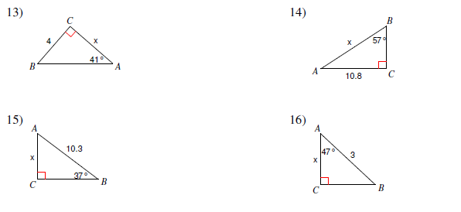
III. Solve the triangle
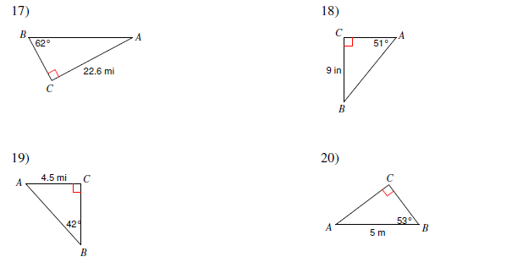
IV. Solve the following word problem.
- A power line snaps in half because of a tornado. It breaks into 2 pieces and forms a right angle with the ground. The top of the power line rests 27 feet from the base of the pole and forms a 20º angle with the ground. Find the original height of the power line before the storm.

Day 2: Angle of Elevation/Depression Application Problems

Angle of Elevation | Angle of Depression

1. A tree casts a 5m shadow. Find the height of the tree if the angle of elevation of the sun is 32.3º.
Sketch: Work: Answer:

2. A ladder 10.4 m long leans against a building that is 1.5 meters away. What is the angle formed by the ladder and the building?
Sketch: Work: Answer:

3. A ladder 8.6 m long makes an angle of 68º with the ground as it leans against a building. How far is the foot of the ladder from the foot of the building?
Sketch: Work: Answer:

4. The angle of depression from the top of a cliff 800 meters high to the base of a log cabin is 37º. How far is the cabin from the foot of the cliff?
Sketch: Work: Answer:

b) How far is the cabin from the top of the cliff?

5. From a point on the ground 500 ft from the base of a building, it is observed that the angle of elevation to the top of the building is 24º and the angle of elevation to the top of a flagpole atop the building is 27º. Find the height of the building and the length of the flagpole.
Sketch: Work: Answer:

6. Mrs. Regan is hiding up in a tree 20 feet away from a giant alien. Looking up to the top of the alien’s head, the angle of elevation is 28 º and looking down at the feet (or what looks like feet) is an angle of depression of 32 º. How tall is the alien?
Sketch: Work: Answer:

Day 2: Trig Elevation/Depression Problems.
1.The angle of elevation of the top of a building from a point 100 feet away from the building is 22°. Find the height of the building.

2. The Sears Tower stands 1,451 feet tall. A person across the street is 30 feet away from the foot of the tower. Find the angle of elevation to the top of the tower.

3. An airplane is flying at a height of 2 miles above the ground. The distance along the ground from the airplane to an airport is 5 miles. Find the airplane’s angle of elevation.

4. The angle of depression of a buoy from a point on a lighthouse 100 feet above the surface of the water is 3°. Find the distance the buoy is from the lighthouse.

5. A bird sits on top of a 15-foot lamppost. The angle of depression from the bird to the feet of an observer standing away from the lamppost is 35°. Find the distance between the bird and the observer.

6. If a plane that is cruising at an altitude of 30,000 feet wants to land at Bush Field, it must begin its descent so that the angle of depression to the airport is 7°. How far is the plane from the airport?

7. From the top of a 35 meter cliff, Lori spots a hiker at an angle of depression of 62°. Assuming Lori can sprout tentacles with which to snatch the hiker from the path (to eat the hiker, natch), how long must Lori’s new demons pawn appendages be to reach the tasty morsel of a hiker?

8. Josee wanted to measure the depth of the sink hole that opened on Amelia Avenue this morning. From one side, she measured the angle of depression to the lowest point on the opposite side to be 35°. She also measured the distance across the sinkhole to be 38 feet. How deep is the sinkhole?

9. Two towers (Barad-dûr and Orthanc) face each other separated by a distance 2000m . As seen from the top of Barad-dur, the angle of depression of the second tower's base is 60° and that of the top is 30°. Based on this, how tall is Orthanc?

10. A plane is 120 miles north and 85 miles east of an airport. Find its straight line distance from the airport.

11. As a hot-air balloon rises vertically, its angle of elevation from a point A, which is 110 kilometers from the point B, which is directly underneath the balloon, changes from 19°to 38°. How far did the balloon rise during that time?

Day 3: Law of Sines
Law of sines suggests that in ANY triangle (not just right triangles) the lengths of the sides are proportional to the sines of the corresponding opposite angles.

Formula:
$$\frac{Big Letters \left(Angles\right)}{Little Letters \left(sides\right)}=\frac{\sin{A}}{a}=\frac{\sin{B}}{b}= \frac{\sin{C}}{c}$$
All are equal! It doesn’t matter which ones you use!

Use the law of sines if you are given a triangle with:
Side-Angle-Angle (SAA)
Side-Side-Angle (SSA)- Ambiguous case

Examples
- SAA (Side-angle-angle)

- SAA

- SAA

- A satellite orbiting the earth passes directly overhead at observation stations in Phoenix and Los Angeles, 340 miles apart. At an instant when the satellite is between these two stations, its angle of elevation is simultaneously observed to be 60⁰ at Phoenix and 75⁰ at Los Angeles. How far is the satellite from Los Angeles?

Day 3: Law of Sines Practice
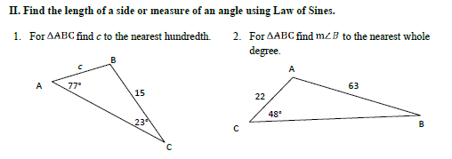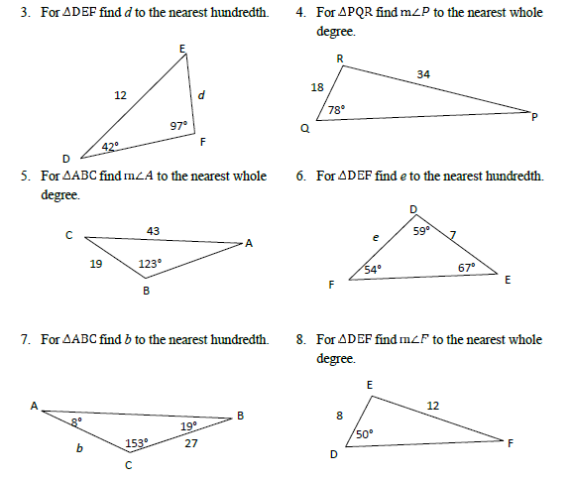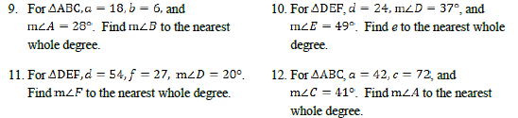

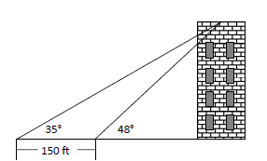
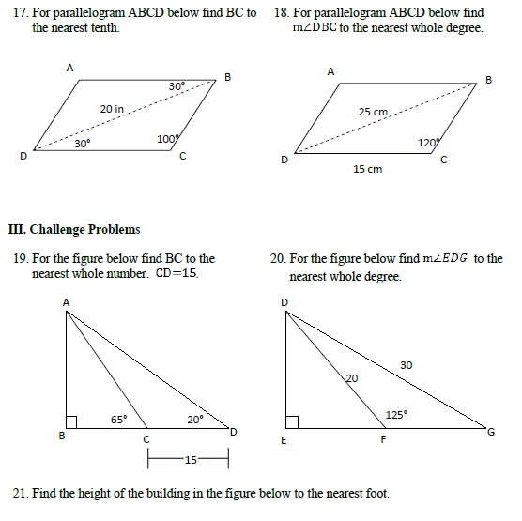

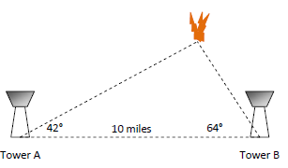

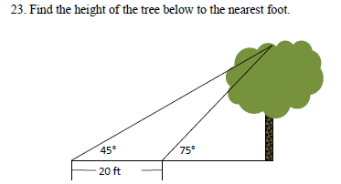

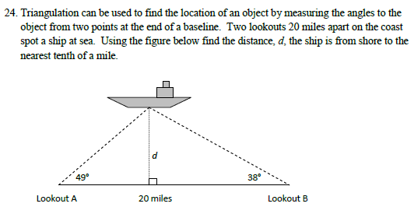

Day 3: The Law of Sines- The Ambiguous Case
If you are given two sides and one angle (SSA), the law of sines could provide 0, 1, or 2 solutions.
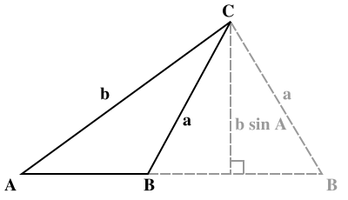
To determine how many solutions, add the supplementary angle of the angle found using the law of sines to the given angle
- If when using the law of sines you get an equation where sin⊖ > 1, then there is no solution
- If when using the law of sines you get an equation where sin⊖ < 1, find both the obtuse and the acute angle, then check to see if an obtuse triangles is possible
  - If an obtuse angle is possible, 2 solutions
  - If an obtuse angle is not possible, 1 solution

∠A= 30, a= 7, c=16

∠A= 30, a= 20, c=16

∠A= 30, a= 10, c=16

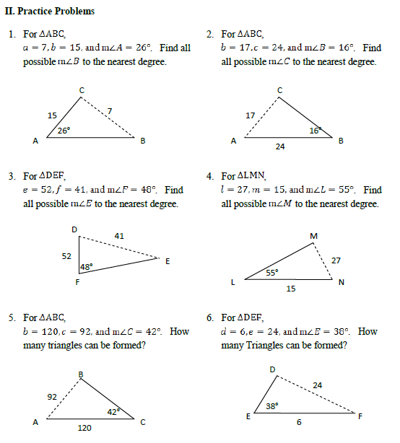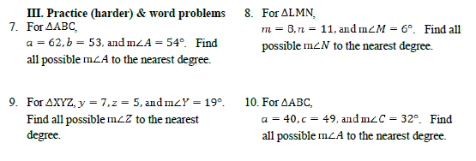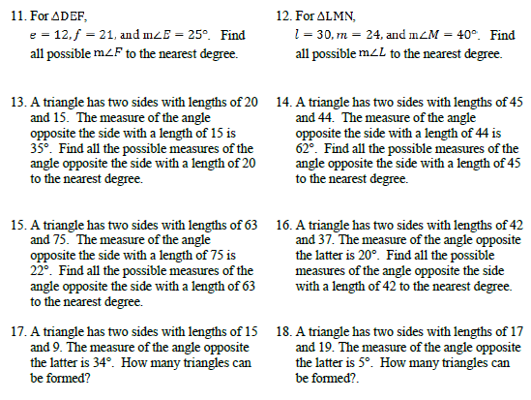
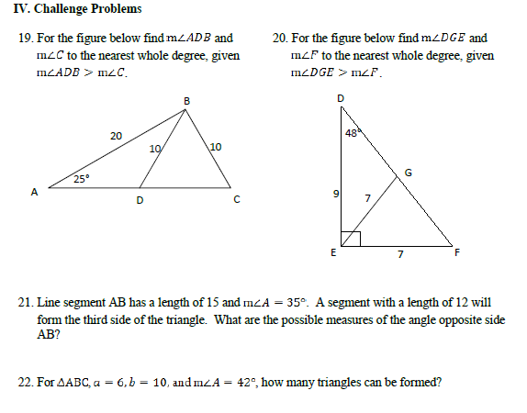

Day 4: Area of a Triangle
The most common formula for area of a triangle is $A=\frac{1}{2}bh$ where b is base and h is height.
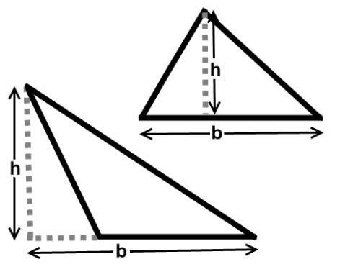
But what if we don’t know the height? GET CREATIVE
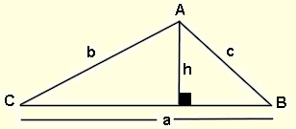
By using the right triangle on the left side of the diagram, and our knowledge of trigonometry, we can state that:
$$\sin{C}=\frac{h}{b}$$
$$bsin C=h$$
Thus, the height can be expressed as $bsin C$

If we substitute this in to our common area formula we get:
$$A=\frac{1}{2}absinC$$
Where a and b are adjacent sides and C is the included angle (THIS HAS TO BE TRUE!)

Example 1: Find the area of a triangle with the sides of length 7 and 9 and the included angle of 72º.

Example 2: Find the area of a triangle with the sides of length 10 and 22 and the included angle of 10º.

Example 3: Find the area of an equilateral triangle with side length of 10.

Example 4: In ΔABC, AB = 12 meters and AC = 20 meters. If the area of the triangle is 77 sq. meters, find the measure of <A, to the nearest degree.

Example 5: A farmer has a triangular field where two sides measure 450 yards and 320 yards. The angle between these two sides measures 80º. The farmer wishes to use an insecticide that costs $4.50 per 100 sq. yards or any part of 100 yds. What will it cost to use this insecticide on this field?

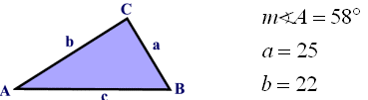
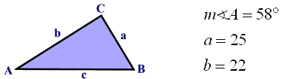
Example 6: Find the area of the triangle below.

- Determine how many triangles can be constructed, then solve the triangle and find its area(s).
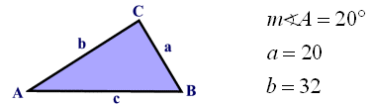

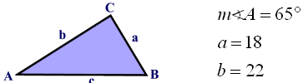

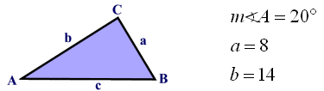

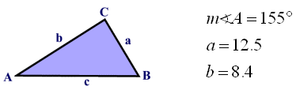

- Find the area of the triangle.
- In ABC, AB = 10, AC = 8, and m<A = 45º. Find the area of ABC, to the nearest tenth of a square unit.

- In an isosceles , the two equal sides each measure 24 meters, and they include an angle of 30º. Find the area of the isosceles triangle, to the nearest sq. meter.

- A triangle has two sides of 30 meters and 26 meters, and the angle between them is an obtuse angle. If the area of the triangle is 300 sq. meters, find the measure of the obtuse angle (to the nearest degree.)
Day 5: Law of Cosines
Law of Cosines is used when you are given the following information:
SSS- Know all three sides and no angles
SAS- Know 2 sides and the angle between them
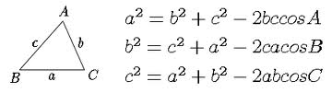
Example 1: In ΔABC, m∠A=39, AC=21 and AB=42. Find side a to the nearest integer.
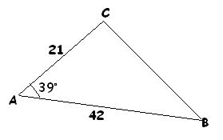

Example 2: In the triangle below, find the measure of angle x.
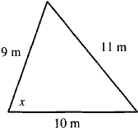
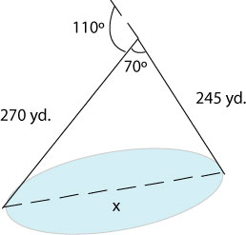
To approximate the length of a lake, a surveyor starts at one end of the lake and walks 245 yards. He then turns 110º and walks 270 yards until he arrives at the other end of the lake. Approximately how long is the lake?

Two ships leave port at 4 p.m. One is headed at a bearing of N 38 E and is traveling at 11.5 miles per hour. The other is traveling 13 miles per hour at a bearing of S 47 E. How far apart are they when dinner is served at 6 p.m.?
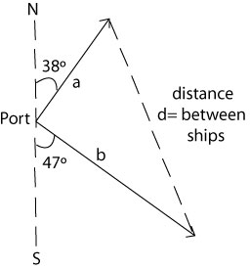

You are heading to Beech Mountain for a ski trip. Unfortunately, state road 105 in North Carolina is blocked off due to a chemical spill. You have to get to Tynecastle Highway which leads to the resort at which you are staying. NC-105 would get you to Tynecastle Hwy in 12.8 miles. The detour begins with a 18 veer off onto a road that runs through the local city. After 6 miles, there is another turn that leads to Tynecastle Hwy. Assuming that both roads on the detour are straight, how many extra miles are you traveling to reach your destination?
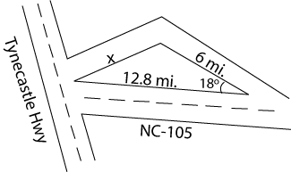
The distance on a map from the airport in Miami, FL to the one in Nassau, Bahamas is 295 kilometers due east. Bangor, Maine is northeast of both cities; its airport is 2350 kilometers from Miami and 2323 kilometers from Nassau. What bearing would a plane need to take to fly from Nassau to Bangor?
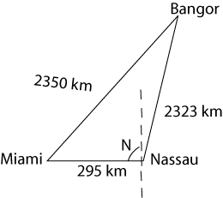

After the hurricane, the small tree in my neighbor’s yard was leaning. To keep it from falling, we nailed a 6-foot strap into the ground 4 feet from the base of the tree. We attached the strap to the tree 3½ feet above the ground. How far from vertical was the tree leaning?
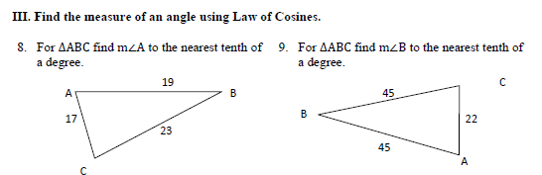
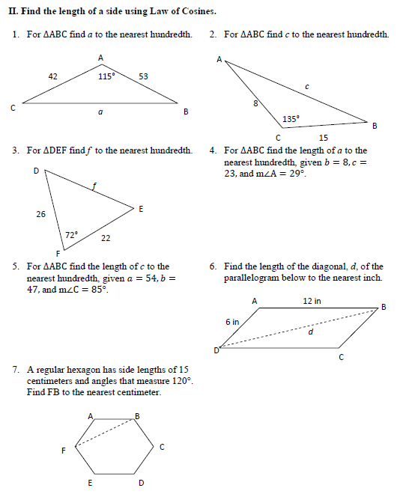

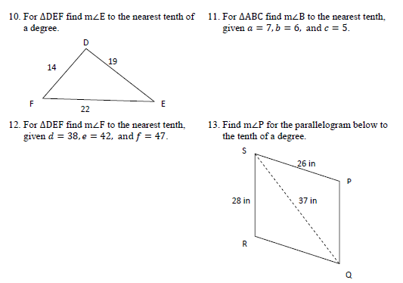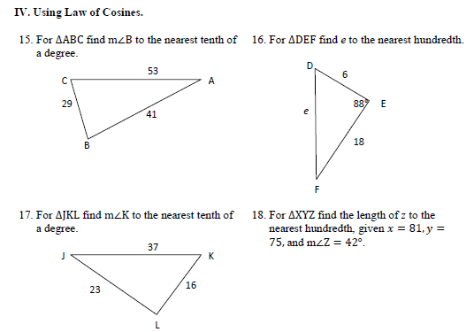
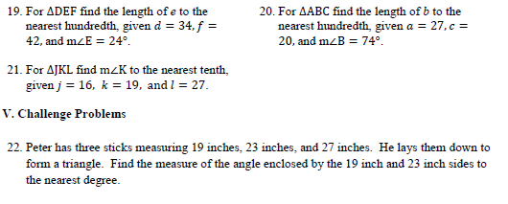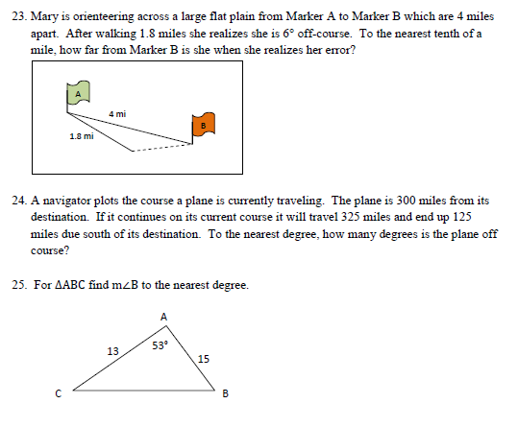

Law of Sines/Cosines Word Problems
- A post is supported by two wires (one on each side going in opposite directions) creating an angle of 80° between the wires. The ends of the wires are 12m apart on the ground with one wire forming an angle of 40° with the ground. Find the lengths of the wires.

- Two ships are sailing from Halifax. The Nina is sailing due east and the Pinta is sailing 43° south of east. After an hour, the Nina has travelled 115km and the Pinta has travelled 98km. How far apart are the two ships?

- 3 friends are camping in the woods, Bert, Ernie and Elmo. They each have their own tent and the tents are set up in a Triangle. Bert and Ernie are 10m apart. The angle formed at Bert is 30°. The angle formed at Elmo is 105°. How far apart are Ernie and Elmo?

- Two scuba divers are 20m apart below the surface of the water. They both spot a shark that is below them. The angle of depression from diver 1 to the shark is 47° and the angle of depression from diver 2 to the shark is 40°. How far are each of the divers from the shark?

- To estimate the length of a lake, Caleb starts at one end of the lake and walks 95m. He then turns and walks on a new path, which is 120° to the direction he was first walking in, and walks 87m more until he arrives at the other end of the lake. Approximately how long is the lake?

- Two observers are standing on shore ½ mile apart at points F and G and measure the angle to a sailboat at a point H at the same time. Angle F is 63° and angle G is 56°. Find the distance from each observer to the sailboat.

- Jack and Jill both start at point A. They each walk in a straight line at an angle of 105° to each other. After 45 minutes Jack has walked 4.5km and Jill has walked 6km. How far apart are they?

- Points A and B are on opposite sides of the Grand Canyon. Point C is 200 yards from A. Angle B measures 87° and angle C measures 67°. What is the distance between A and B?

- A 4m flag pole is not standing up straight. There is a wire attached to the top of the pole and anchored in the ground. The wire is 4.17m long. The wire makes a 68° angle with the ground. What angle does the flag pole make with the wire?

Day 7: Unit 4 Review
7.2 Things to Know!
- Solve a right triangle, SOH CAH TOA, ,
- Use SOH CAH TOA to solve RIGHT triangles. (Problems that say angle of elevation/depression)
To review 7.2, problems on page 494 (13 – 19 odd) Note, there are more here if you need more practice.

7.4 Things to Know!
- Law of Sines - .
- Use if you have ASA or AAS (that is not a right triangle), then you will only produce 1 triangle
- Use if you have SSA (that is not a right triangle), then you could produce 0, 1 or 2 triangles. If sin A>1, then no solution. If sin A < 1, consider 2 triangles!!!!
To review 7.4, problems on page 494 (55, 56, 59, 60)

7.5 Things to Know!
- Law of Cosines - , ,
- Use Law of Cosines if you have SAS or SSS.
To review 7.5, problems on page 494 (57, 58) and page 499 (16)

Area of a Triangle
- The area of a triangle with sides of lengths a and b and with included angle is .
To review area of a triangle, problems on page 497 (66, 67)

Mixing up 7.2, 7.4, 7.5!

1. A guy wire from the top of the transmission tower at WJBC forms a 75° angle with the ground at a 55-foot distance from the base of the tower. How tall is the tower?

2. In order to determine the distance between two points A and B on opposite sides of a lake, a surveyor chooses a point C that is 900 ft from A and 225 ft from B. If the measure of the angle at C is 70°, find the distance between A and B.

3. Two markers A and B are on the same side of a canyon rim 56 ft apart. A third marker, C, located across the rim, is positioned so that ∠BAC = 72° and ∠ABC = 53°. Find the distance between C and A.

4. A civil engineer wants to determine the distances from points A and B to an inaccessible point C, as shown. From direct measurements, the engineer knows that AB = 25m, ∠A = 110°, and ∠B = 20°. Find AC and BC.

5. The base of a ladder is 6ft from the building, and the angle formed by the ladder and the ground is 73°. How high up the building does the ladder touch?

6. A car travels along a straight road, heading east for 1 hour, then changing to northeast direction at 135º onto another road, traveling for 30 min. If the car has maintained a constant speed of 40mph, how far is it from its starting point?

7. Suppose you want to fence a triangular lot. If two sides measure 84 feet and 78 feet and the angle between the two sides is 102º, what is the length of the fence to the nearest foot?

8. Two surveyors 560 yards apart sight a boundary marker C on the other side of a canyon at angles of 27º and 38º. Their measurements will be used to plan a bridge that spans the canyon. How long will the bridge be, to the nearest tenth.

