**Unit 5: Circle Trig**

**Objective 2.04  Use trigonometric (sine, cosine) functions to model and solve problems; justify results.**

* Solve using tables, graphs, and algebraic properties.
* Create and identify transformations with respect to period, amplitude, and vertical and horizontal shifts.

|  |  |  |  |  |
| --- | --- | --- | --- | --- |
| **Day** | **Topic** | **Students will be able to:** | **Activity** | **Hwk – from textbook** |
| 1  Thursday,  October 17 | 5.1 Angle and Radian Measure | * Convert between degrees and radians. * Draw angles in standard position. * Find coterminal angles. |  | ***Page 453***  #2-18 evens  #32-42 evens |
| 2  Friday,  October 18 | 5.1 Angle and Radian Measure | * Find the length of a circular arc. * Use linear and angular speed to describe motion on a circular path. |  | ***Page 454-455***  #44-62 evens |
| 3  Wed/Thurs  October 24/25 | 8.1 Unit Circle | * Intro to Unit Circle |  | ***Page 514-515***  #2, 4, 18-26 even, 34-44 even |
| 4  Friday,  October 26 | 5.3/5.4Trig Functions of any Angle | * Use a unit circle to define trig functions of real numbers. * Use reference angles to evaluate trig functions. |  | ***Page 524***  #2-20 even  #26-32 even |
| 5  Tuesday,  October 29 | 5.5 Graphs of Sine and Cosine Functions | * Understand the graph of y = sinx. * Understand the graph of y = cosx. | **Discovery Lesson –Explore graphs of sine and cosine.** | ***Finish Project*** |
| 6  Wednesday,  October 30 | 5.5 Graphs of Sine and Cosine Functions | * Graph variations of y = sinx and y = cosx. * Use vertical shifts. |  | ***Page 538***  #2-30even |
| 8  Thursday,  October 31 | Review |  | Review for test/finish up projects |  |
| 9  Friday,  November 1 | **TEST** | **Show mastery on circular trigonometry! ☺** | **TEST** |  |

**Midterm Review: Monday 10/21 and Tuesday 10/22**

**Midterm: 1st/3rd Wednesday 10/23, 2nd/4th Thursday 10/24**

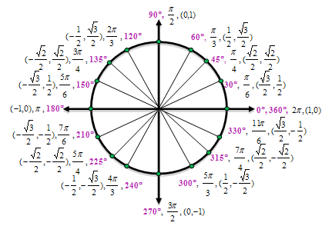

**Day 1 Notes: Angles and Radian Measure**

**Positive Angle:**

**Negative Angle:**

**Angles in Standard Position**

An angle is in _______________________________ if it is draw in the xy-plane with its _________________ at the

____________ and its initial side on the __________________________________.

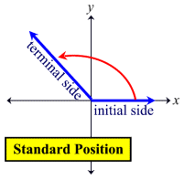

**Example: Draw the given angle in standard position. State the quadrant the terminal side is in.**

**1. 450 2. 2250 3. 1000 4. −600**

**Measurements of Angles:**

**Degree:**

**Radians:**

**-**The circumference of a circle with radius 1 is _____________ so a complete

revolution has made ____________ radians.

**-**A straight angle (or ___________ of a circle) has measure ______________ radians.

**Converting Radians and Degrees:**

**Examples:**

1. Express 60o in radians
2. Express $\frac{π}{6}$ rad in degrees

**Coterminal Angles**

Two angles in _______________________ are ____________________ if their sides coincide.

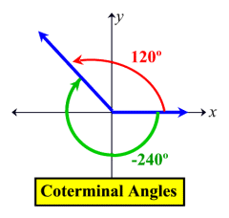

To find angles that are coterminal, add any multiple of ____________ for degrees or _______________ for radians.

**Examples**:

1. Find three angles that are coterminal with the angle $θ=30°$ in standard position
2. Find three angles that are coterminal with the angle $θ=\frac{π}{3}$ in standard position
3. Find an angle with a measure between 0o and 360o that is coterminal with the angle of measure 1290o in standard position.

**Day 1 Practice:**

For questions 1-9, change the given angle to radians.

1. 315° 3) -60°

4) 212° 5) -168°

6) 12.5° 7) -310°

8) 600° 9) -720°

For questions 10-17, change the given angle to degrees.

10)  11) 

12)  13) 

14)  15) 

16)  17) 

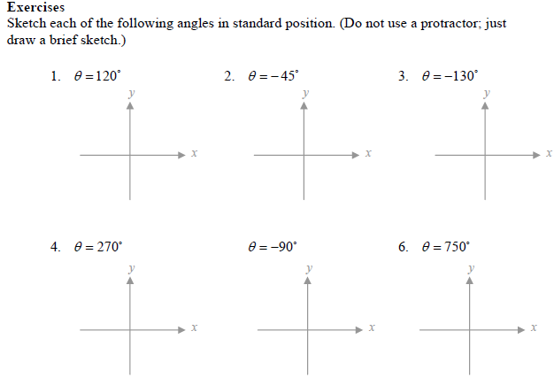

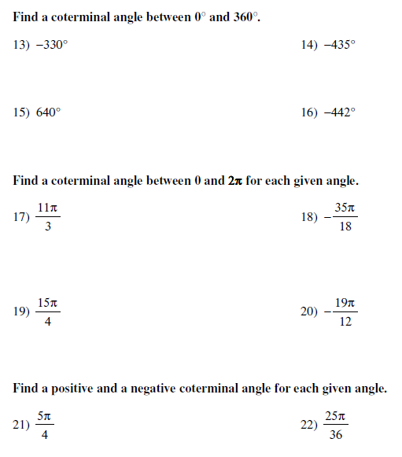

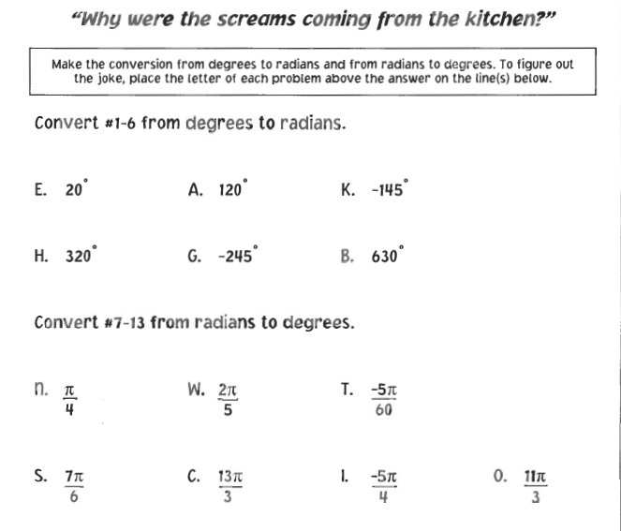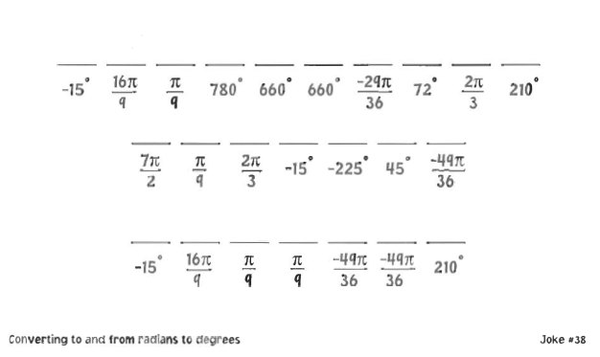

**Length of Circular Arc**

In a circle of radius, *r*, the length *s* of an arc that subtends a central angle of radians is:



*True if and only if  is in radians! If the angle given is in degree measure, use your conversion rule from yesterday to change the angle in degree measure to radian measure by multiplying by.

Examples:

1. Find the length of an arc of a circle with radius 10 m that subtends a central angle of 30º.
2. A central angle in a circle of radius 4 m is subtended by an arc of length 6 m. Find the measure of  in radians and in degrees.
3. Memphis, TN and New Orleans, LA lie approximately on the same meridian. Memphis has latitude 35ºN and New Orleans 30ºN. Find the distance between the two cities. (Radius of earth is 3960 miles)

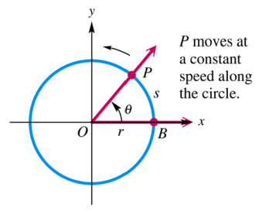

**Angular and Linear Speed (Velocity)**

[**https://www.youtube.com/watch?v=jh9gRYAuau8**](https://www.youtube.com/watch?v=jh9gRYAuau8)

Sometimes it is important to know how fast a point is moving (___________________________) or how fast a central angle is changing (____________________________)

Linear Speed (Velocity) when not a circular motion can be found by d = rt. Or **d = vt**

**Angular Speed (Velocity)**: The measure of how fast an angle is changing, *angular velocity*, $ω$ (omega)

$$ω=\frac{θ}{t} where θ is measured of angle in radians at time, t$$

This is often expressed in rpms (or revolutions per minute). To be angular speed, you need to convert to radians per time.

**Example:** A record rotates at a rate of 50 rpms. Determine the angular speed in radians per second.

(One rotation is 360 degrees, or 2π radians—change to radians)

**Linear Speed (Velocity) around a circle:** If *P* is a point on a circle of radius *r*, and *P* moves a distance *s (arclength)* on the circumference of the circle in an amount of time *t*, then you can find the linear velocity (v) if you replace the distance with the arclength traveled (s).

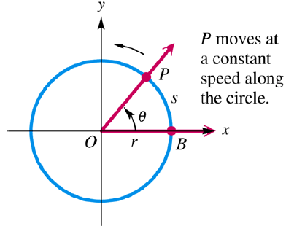 but since s = rѲ, we can know that

$$v=\frac{rθ}{t} or v=rω or v=r\frac{θ}{t}$$

If a point is moving with uniform circular motion on a circle of radius *r*, then the linear velocity *v* and angular velocity $ω$ of the point are related by the formula

$$v=rω$$

**Example:** A tire with radius of 9 inches is spinning at 80 revolutions per minute.

1. Find the angular speed of the tire in radians per second
$$ω=\frac{θ}{t}$$

2. Find the speed in inches per minute and miles per minute

$$v=rω or v=r\frac{θ}{t}$$

**Example**: Find the angular velocity in radians per minute of a Ferris wheel 250 ft in diameter that takes

45 seconds to rotate once. Leave answer in terms of π.

b. If you sat on the rim of this Ferris wheel, what would your linear velocity be?

Example: A car is traveling at a speed of 45 mph. Find the angular velocity of a tire in revolutions per minute (rpm) if the diameter of ea

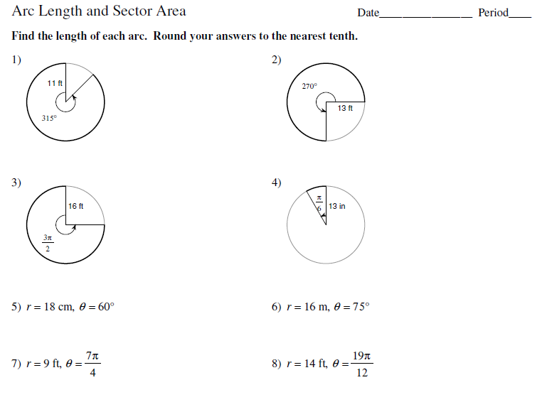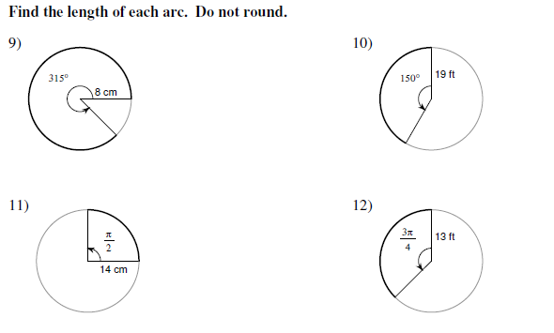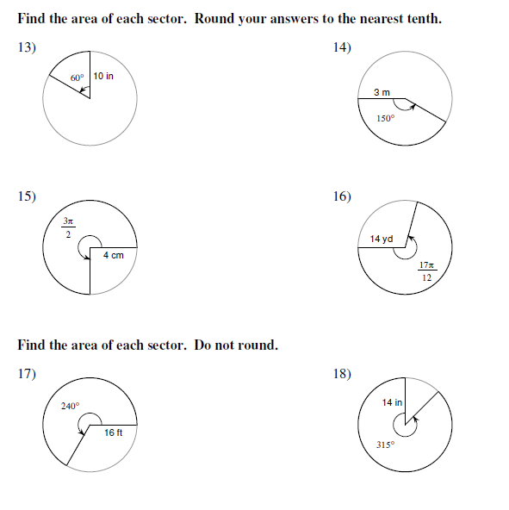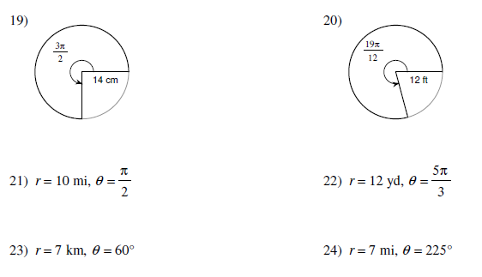

**Day 2 Angles and Radian Measure Applications**

1. The minute hand of a clock moves from 12 to 2 o’clock, or 1/6 of a complete revolution. Through how many degrees does it move? Through how many radians does it move?
2. Find the distance s covered by a point moving with linear velocity *v* = 55 mi/hr and *t* = 0.5 hr.
3. A bicycle traveled a distance of 100 meters. The diameter of the wheel of this bicycle is 40 cm. Find the number of rotations of the wheel.
4. The wheel of a car made 100 rotations. What distance has the car traveled if the diameter of the wheel is 60 cm?
5. The wheel of a machine rotates at the rate of 300 rpm (rotation per minute). If the diameter of the wheel is 80 cm, what are the angular (in radian per second) and linear speed (in cm per second) of a point on the wheel?
6. The Earth rotates about its axis once every 24 hours (approximately). The radius R of the equator is approximately 4000 miles. Find the angular (radians / second) and linear (feet / second) speed of a point on the equator.
7. The diameter of the Ferris wheel is 250 *ft* and one complete revolution takes 20 minutes, find the linear velocity, in miles per hour, of a person riding on the wheel.
8. Earth travels about the sun in an orbit that is almost circular. Assume that the orbit is a circle with radius 93,000,000 mi. Its angular and linear speeds are used in designing solar-power facilities.
9. Assume that a year is 365 days, and find the angle formed by Earth’s movement in one day.
10. Give the angular speed in radians per hour.
11. Find the linear speed of Earth in miles per hour.

**Day 3 Notes** : **The Unit Circle**

WARM- UP:

1. Find 2 positive and 2 negative angles that are coterminal with the following angles:

* 5π/6
* -60°

2. Find an angle between 0 and 2π that is coterminal with 51π/11. Which quadrant does the angle lie in?

3. A circle has a radius of 3 inches. A central angle θ is subtended by an arc of length 15 inches. Find the measure of θ in radians and in degrees.

4. If a carousel is rotating at 4.5 revolutions per minute, what is the angular speed?

If a horse on the carousel is 10 feet from the center, what is the linear speed of the horse?

------------------------------------------------------------------------------------------------------------------------------------------------------------

**Reference angles**: A POSITIVE, ACUTE angle formed by the terminal side of an angle and the x-axis.

Ex. 135° Ex. 240° Ex. 330° Ex. 3π/4 Ex. 7π/6 Ex. 23π/6

You Try: 1. 2π/3 2. 150° 3. -320° 4. 7π/4 5. 560° 6. -2π/3

For circular trigonometry, you can still use SOH CAH TOA to determine the values of your trig functions using the “reference triangle” (acute triangle formed with the horizontal and the reference angle)

* Horizontal: x Vertical: y Hypotenuse: r



**Remember: x2+y2=r2

* Sin Ѳ = csc Ѳ =
* cos Ѳ = sec Ѳ =
* Tan Ѳ = cot Ѳ =

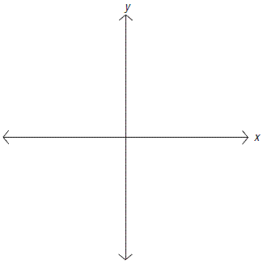Graph an angle in standard position with point **P (1, 3)** on the terminal side and find all six trig values.

Graph point, P (-2, -4) and find all 6 trig values.



To determine if the trig values are positive or negative, look at the quadrant: **A**ll **S**tudents **T**ake **C**lasses

**A**

**S**

**T**

**C**

Example: If the tan θ = -1/3 and the sin θ > 0, find the values of the 6 trig functions

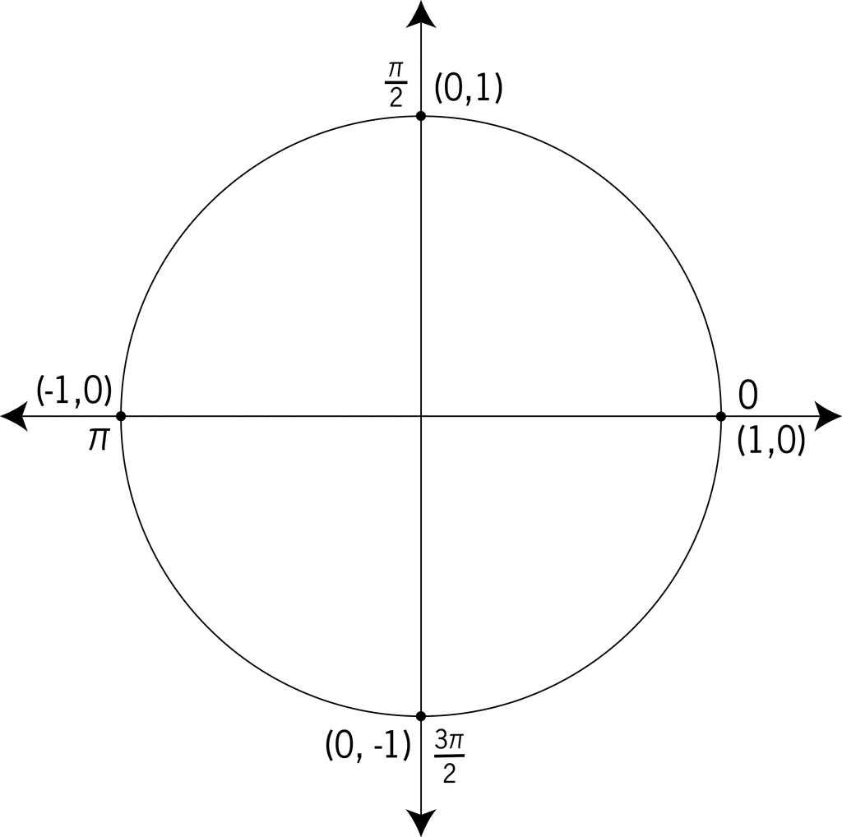When referring to the **“unit circle”**, the radius (r) is always equal to 1. So points on the terminal side of an angle on the unit circle correspond to cosine and sine.

P(cos Ѳ, sin Ѳ) ONLY if on the unit circle

**Need to know: 00, 300, 450, 600, 900 or 0, π/6, π/4, π/3, π/2 (in radians)**

**Can use Special Right Triangles!!!**

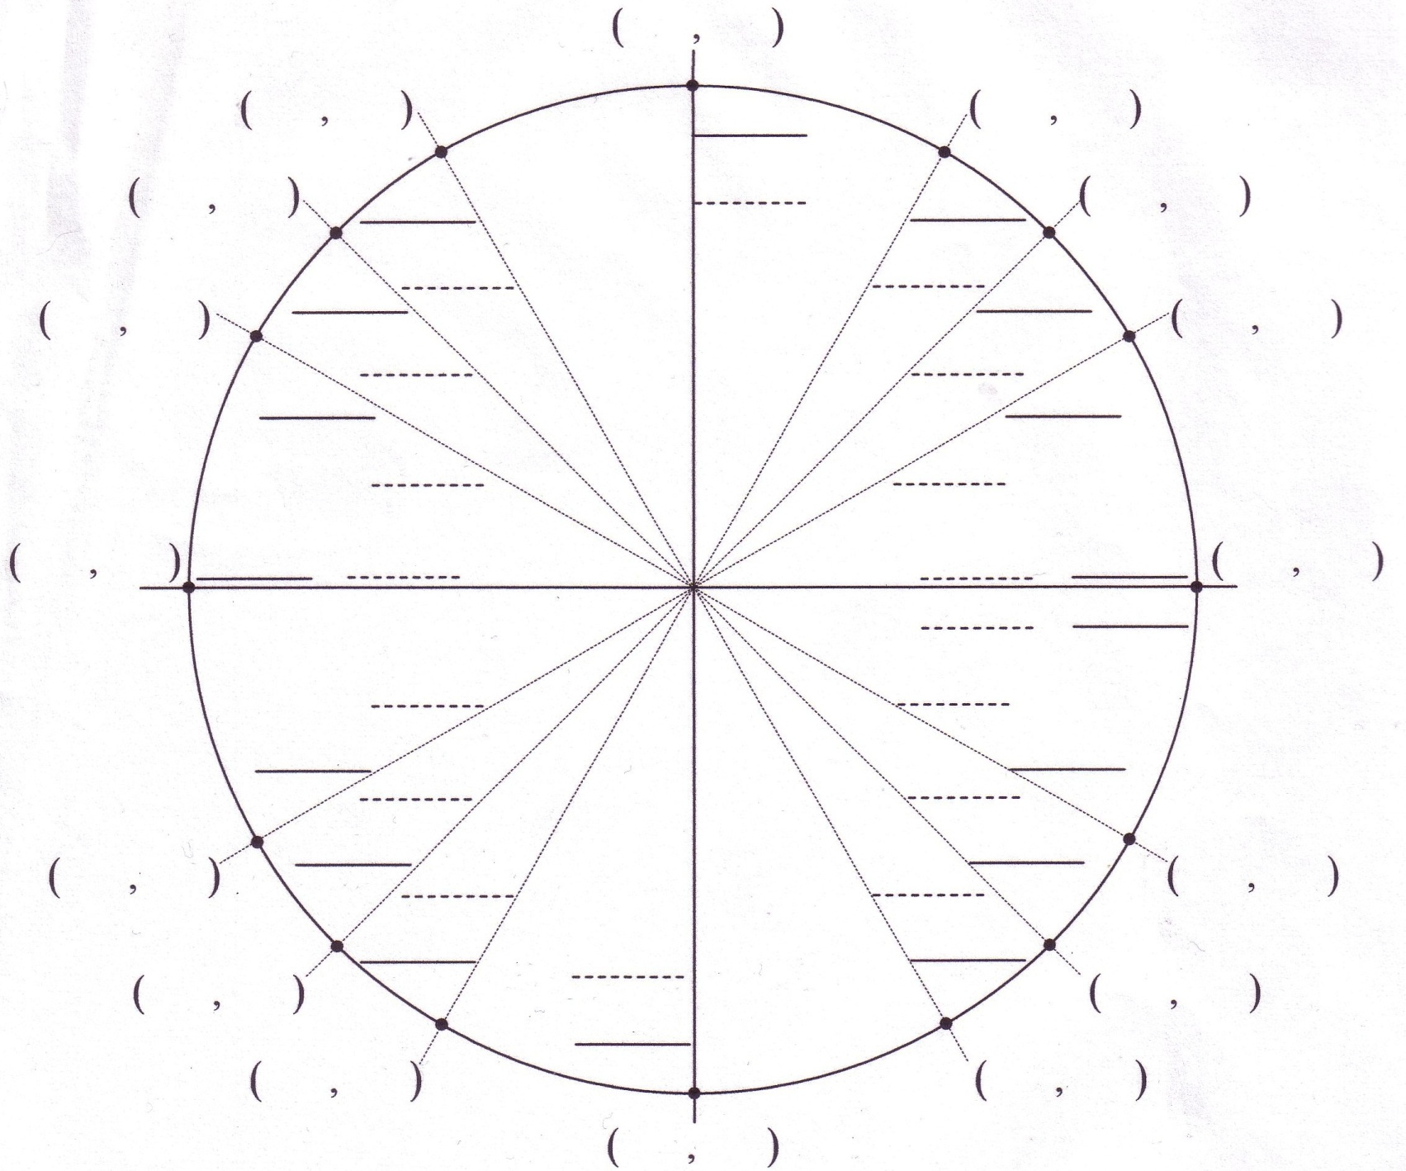

Find the EXACT value of any angle **(only give ONE number, NOT a point!!)**:

1. Find the coterminal angle between 0° and 360°.
2. Determine the quadrant of the angle (sign)
3. Find the reference angle
4. KNOW your unit circle!!! Remember that **x = cos Ѳ, y = sin Ѳ, and y/x = tan Ѳ**

Ex. Find the sin 480° Ex. Find the cos 210° Ex. Find the tan -135°

1.

2.

3.

4.

Ex. Find the cos 17π/6 Ex. Find the tan 11π/3

1.

2.

3.

4.

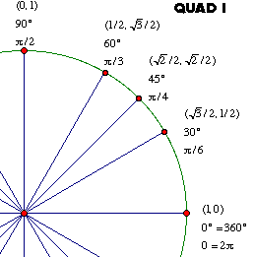

**Homework (Circular trig VALUES):**

Find all six trigonometric ratios for the given point. (If any are undefined, say so.)

1) (7, 24) 2) (8, 15) 3) (5, -12)

4) (-4, 0) 5) (-2, -2) 6) (-3, )

Find the **exact value** of the trigonometric function at the given angle. Do NOT use your calculator!

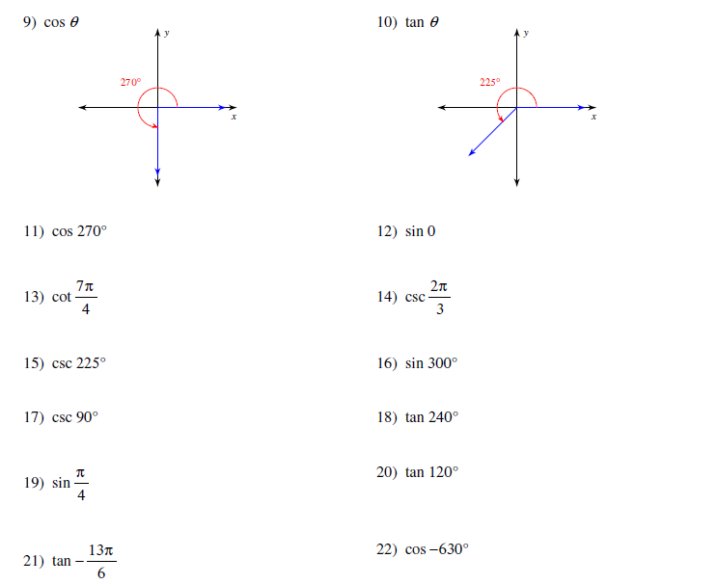

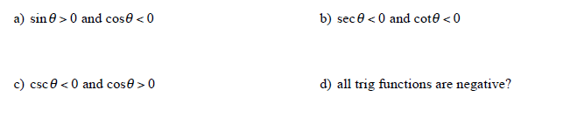23. In what quadrant is…

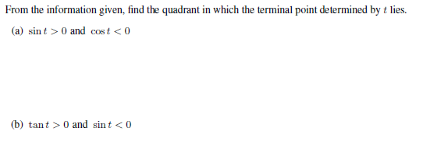

**Day 6: Graphs of Sine and Cosine**

From your discovery activity yesterday, you should have discovered that sine and cosine values repeat themselves. Thus, the sine and cosine functions are ___________________.

A function is ____________________ if there is a positive number p such that f(t + p) = f(t) for every t. The least such positive number is called the __________.

Y = sin x

graph (goes 0, 1, 0, -1, 0 on a period of 2π)

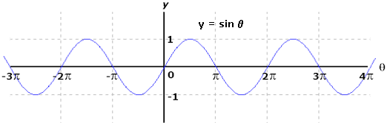

Y = cos x

graph (goes 1, 0, -1, 0, 1 on a period of 2π)

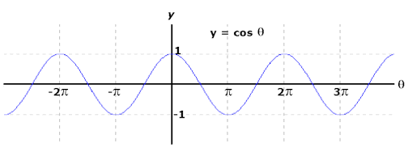

The sine and cosine curves

$$y=A\sin{B\left(x-C\right)+D} and y=A\cos{B\left(x-C\right)+D} C>0$$

$Amplitude:$

* $Period$:
$Phase Shift:$

* Vertical Shift:

Determine the amplitude, period, phase shift and vertical shift of the given function when applicable.

AFM Study Guide for Unit 8 Test Name _______________________

**I. Find the radian measure that corresponds to the given degree or radian measure. (Be exact!)**

1. 70 2. 420 3. -240 4.  5.  6. 1.2

**II. Find the reference angle for the following measures.**

7. 24 8.  9. 750 10.  11. 12.

**III. Find the following from the given information.**

13. Find the length of an arc of a circle of radius 8 m if the arc subtends a central angle of 1 radian.

14. Find the measure of a central angle  (in radians and degrees) in a circle of radius 5 ft if the angle is subtended by an arc of length 7 ft.

15. A circular arc of length 100 ft subtends a central angle of 70. Find the radius of the circle.

16. Find the area of a sector with central angle 52 in a circle of radius 200 ft.

17. A sector in a circle of radius 25 ft has an area of 125 ft. Find the central angle of the sector (in radians and degrees).

**IV. Find the exact values of the following.**

18. sin 315 19. tan (-135) 20. cos 21. sin 405 22. cos 23. tan 4

**V. Find the value of the SIX trigonometric functions of  from the information given.**

24. tan = 4, sin<0 25. The point (-4,5) is on the terminal side of $θ$

**VI. Find the quadrant in which lies from the information given.**

26.  27. 

**VII. Graph the following. State the amplitude and period, phase shift and vertical shift. Then graph them.**

28. 3cos(x+2) -1 29. –sin(2x)+4 30. 2sin(x)-1

**VII. Answer the following questions about linear and angular speed.**

31. A phonograph record has a radius of 3 inches and revolves at 45 RPM. Find the linear speed of the

outside edge of the record.

32. The angular speed of a propeller on a wind generator is 10.3 revolutions per minute. Express this angular speed in radians per minute.

33. The propeller of an airplane has a radius of 3 ft. The propeller is rotating at 2250 revolutions per minute. Find the linear speed, in ft per minute, of the tip of the propeller.

**VIII. Find the terminal points for the following.**

34.  35.  36. 

**IX. Terminal points.**

37. If (-1, -5) is a point on the terminal side of angle θ, find the exact value of each of the six trig functions.

38. If cosθ = 2/5, and sinθ < 0, find the remaining trig functions.

**X. Find the quadrant in which lies from the information given.**

39.  40. 