Given the graphs below, which is f(x), f’(x), and f’’(x) and why.

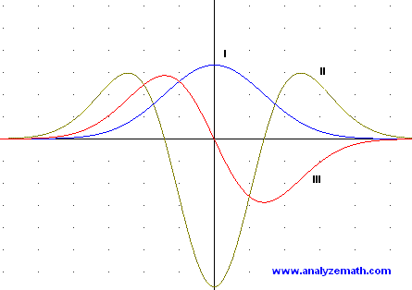

2.

[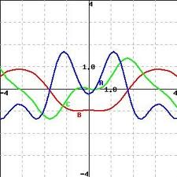](http://www.google.com/imgres?um=1&safe=active&sa=N&rls=com.microsoft:en-us:IE-SearchBox&hl=en&tbm=isch&tbnid=k49hM7bz6xKuXM:&imgrefurl=http://www.chegg.com/homework-help/questions-and-answers/identify-graphs-blue-b-red-c-green-graphs-function-f-x-derivatives-f-x-f-x-_______________-q1142675&docid=sEaNzvCXnLlQpM&imgurl=http://s3.amazonaws.com/answer-board-image/77225348-dbd0-4c73-902d-b3c6d24537c6.jpeg&w=299&h=299&ei=DvZOUpjgG4We9QSSjoDgDA&zoom=1&iact=hc&vpx=413&vpy=309&dur=2078&hovh=225&hovw=225&tx=110&ty=137&page=1&tbnh=135&tbnw=135&start=0&ndsp=28&ved=1t:429,r:16,s:0,i:129)

3.

