***AFM Piecewise Functions Name:***

**Part I**. Carefully graph each of the following. Identify whether or not he graph is a function. Then, evaluate the graph at any specified domain value. You may use your calculators to help you graph, but you must sketch it carefully on the grid!



1. 

Function? Yes or No





2. 

Function? Yes or No



3. 



Function? Yes or No





4. 

Function? Yes or No



5. 



Function? Yes or No





6. 

Function? Yes or No



**Part II.** Write equations for the piecewise functions whose graphs are shown below. Assume that the units are 1 for every tic marc.

7. 8.



9. 10.

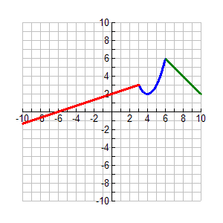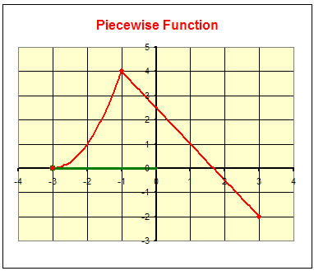

11. 12.

1. An air conditioning salesperson receives a base salary of $2850 per month plus a commission. The commission is 2% of the sales up to and including $25,000 for the month and 5% of the sales over $25,000 for the month.

a. Write a piecewise function that relates the salesperson total monthly income based off or his/her sales for the month.

b. Sketch an accurate graph of this piecewise function

c. Determine the salesperson’s monthly income if his/her sales were $43,000 for the month.



2. A certain country taxes the first $20,000 of an individual’s income at a rate of 15%, and all income over $20,000 is taxed at 20%.

a. Al makes $16,000. Betty makes $36,000. How much is each taxed?

b. Write a piecewise function T that specifies the total tax on an income of x dollars.

c. Make a graph of T. Be sure to plot the points from part a!

d. Catina is taxed $5000. What is her income?



3. A paperback sells for $12. The author is paid royalties of 10% on the first 10,000 copies sold, and 15% on any additional copies.

a. When the 6,000th book is sold, how much will the author earn on that sale?

b. When the 12,000th book is sold, how much will the author earn on that sale?

c. Let x be the number of copies sold. Write a piecewise function for R (the royalty payment earned on that sale) in terms of x.

d. How many copies have to be sold in order for the author to have earned $30,000?

1. *Texting Plans*: Texting from T-mobile costs $.15 per text with no plan. In addition, they offer three other texting plans, shown to the right, that include a certain number of texts with additional texts over costing $.15 per text. Decide which plans are linear piecewise functions and which are not piecewise (circle your answer).



* 1. No plan – Piecewise? Yes or No
  2. 400 text plan– Piecewise? Yes or No
  3. 1000 text plan– Piecewise? Yes or No
  4. Unlimited text plan– Piecewise? Yes or No

1. If you said that No plan and Unlimited plan were NOT piecewise ...you are wise. Now, write the function rules for each where *x* is the number of texts and *f(x)* is the total monthly cost.
   1. No plan b. 400 text plan c. 1000 text plan d. Unlimited text plan
2. My daughter uses approximately 1200 texts per month. How much would this cost me under each plan?
   1. No plan b. 400 text plan c. 1000 text plan d. Unlimited text plan
3. I utilize about 90 texts per month. Which plan should I purchase for my phone? Convince me with math!
4. Give the interval number of texts that would make each of these plans the best one to purchase (this information would be good to give to our sales people when they are advising customers on which plan to purchase).
   1. No plan b. 400 text plan c. 1000 text plan d. Unlimited text plan